**Create and deploy Static e-commerce shoes-shop website on cloud using azure cloud provider**

**A Project Report**

**Submitted By**

**RIYA VIJAY SHUKLA**

**Project Guide:** **Jhon Devassy, Vikram Patil,**

**Suraj Waghmare**



**AMBERNATH, 421501**

**MAHARASHTRA**

**2023-2024**

**Name and Signature of the Students**

Riya Vijay Shukla

## ABSTRACT

In this project, we will create and deploy a static e-commerce shoe shop website using Azure as our cloud provider. The website will showcase various shoe products and allow users to browse, view product details, and make purchases. This project will leverage Azure's infrastructure and services to ensure the website's scalability, reliability, and security. Design the static website, including web pages for product listings, individual product pages, a shopping cart, and a checkout process. Design the static website, including web pages for product listings, individual product pages, a shopping cart, and a checkout process.

## TABLE OF CONTENT

#### Chapter 1:Introduction…………………………………………….

1.1 Background

1.2 Research Objectives

1.3 Purpose

1.4 Scope

**2. Chapter 2:Survey of Technologies………………………………...**

2.1 Existing System

* 1. Proposed System
  2. Planning and Desing

2.4 Technology Survey

**3. Chapter 3:Requirements and Analysis…………………………….**

* 1. Problem Statement
  2. Software or hardware Requirements.
  3. Conceptual Model

**4. Chapter 4:Creating shoes-shop Static website…………………….**

* 1. Architecture
  2. Code

**5. Chapter 5:Deploy shoes-shop website on azure cloud…………….**

* 1. Create virtual Network
  2. Create Virtual machine
  3. Create Virtual Machine for Database
  4. Create Azure MySOL Database
  5. Create Azure CDN
  6. Deploy code on virtual machine using Github
  7. Create traffic manager
  8. Create DNS zone for hosting
  9. Monitor website , Alert

**6. Chapter 6:Conclusion………………………………………………**

## INTRODUCTION

Creating and deploying a static e-commerce shoe shop website on the Azure cloud platform is an excellent way to establish an online presence for your shoe business. Azure offers a robust and scalable infrastructure that can provide the reliability and security needed to run your e-commerce site effectively. In this guide, we'll take you through the process of setting up your website on Azure. In today's digital age, establishing an online e-commerce presence is crucial for the success of any retail business. Whether you're a small shoe boutique or a large footwear retailer, creating a website that allows customers to browse and purchase your products can significantly expand your customer base and boost sales. Azure, Microsoft's cloud computing platform, provides a reliable and scalable environment to host your e-commerce site. Our Azure-powered website ensures lightning-fast performance, secure transactions, and an impeccable user experience. Azure's robust infrastructure guarantees 24/7 availability, assuring you can shop for your favorite shoes at any time, from anywhere in the world. Explore our extensive collection of sneakers, heels, boots, and more, and enjoy a user-friendly interface that makes browsing and shopping a breeze. With Azure's cloud resources, we can effortlessly scale to meet peak demand during sales and promotions, ensuring you never miss out on the latest trends.

## 1.1 BACKGROUND

In the early 2000s, the e-commerce landscape witnessed the emergence of online shoe shops, marking a significant shift in the way people shopped for footwear. These websites aimed to provide customers with a convenient and extensive platform for browsing, selecting, and purchasing shoes from the comfort of their homes. The background of these e-commerce shoe shops is rooted in the digital revolution and the growing consumer preference for online shopping. With the advent of secure online payment methods and advancements in web technology, it became feasible to create user-friendly, visually appealing platforms for showcasing a wide range of shoe brands and styles. These websites offered various advantages, such as a vast product catalog, detailed product descriptions, high-quality images, and customer reviews, empowering shoppers to make informed choices. Additionally, e-commerce platforms streamlined the purchasing process, offering features like wish lists, cart management, and easy returns. These websites offered various advantages, such as a vast product catalog, detailed product descriptions, high-quality images, and customer reviews, empowering shoppers to make informed choices. Additionally, e-commerce platforms streamlined the purchasing process, offering features like wish lists, cart management, and easy returns.

## 1.2 RESEARCH OBJECTIVES

Creating and deploying a static e-commerce shoe shop website on the Azure cloud platform is an excellent way to establish an online presence for your shoe business. Azure offers a robust and scalable infrastructure that can provide the reliability and security needed to run your e-commerce site effectively.

The followings are the objectives of this project:

* **Scalability**: Azure allows you to easily scale your website resources up or down to meet varying demands, ensuring a seamless shopping experience for users during peak times
* **Reliability:** Azure offers high availability and redundancy, minimizing downtime and ensuring the website is accessible 24/7.
* **Security:** Azure provides robust security features, including DDoS protection, identity management, and data encryption, to safeguard both user data and transactions.
* **Global Reach:** Azure's global network of data centers ensures that your website loads quickly for users worldwide, thanks to Azure CDN and various regional data centers.
* **Cost Management:** Azure's pay-as-you-go model helps you control costs by only paying for the resources you use.
* **Integration:** Azure offers a wide range of services for database integration, authentication, and payment processing, simplifying the development process.

**1.3 PURPOSE**:

The purpose of the Azure Shoe Store project is to create and deploy a static e-commerce website dedicated to selling shoes.

This website serves as a platform for customers to browse, select, and purchase a wide range of footwear.

Leveraging Microsoft Azure as the cloud provider, this project aims to provide a reliable, secure, and scalable online shopping experience.

Azure allows the website to seamlessly handle varying levels of traffic. It can effortlessly scale resources up or down, ensuring a smooth user experience during peak shopping seasons or special promotions.

**1.3 SCOPE**:

* In this project, we aim to create and deploy a static e-commerce shoe shop website on the Azure cloud platform.
* This endeavor involves a combination of web development, cloud infrastructure, and e-commerce functionality.

**1.4 APPLICABILITY**:

This project can be applied to any e-commerce business that wants to establish an online presence, improve user experience, reach a global audience, and leverage cloud capabilities for scalability, reliability, and security.

Whether you are a small startup or a large enterprise, Azure provides a versatile platform for your e-commerce needs.

**CHAPTER - 2 SURVEY OF TECHNOLOGIES**

## 2.1 EXISTING SYSTEM

## Pros:

## Dynamic Features: Traditional e-commerce websites can offer advanced features like user accounts, shopping carts, and real-time product updates.

## Customization: You have more control over the design and functionality of your website.

## Database Integration: You can manage product data, user information, and orders using a database.

## Cons:

## Costly: Maintaining a dynamic e-commerce website can be expensive due to hosting, database, and development costs.

## Security Concerns: Dynamic websites are more vulnerable to security threats and require regular updates and maintenance.

## Scaling Challenges: Handling traffic spikes and scaling infrastructure can be complex and costly.

## 4.Complexity: Setting up and maintaining a dynamic e-commerce website is more complicated than a static site.

## 2.2 PROPOSED SYSTEM

**Proposed System**

**Pros:**

* Cost-Efficient: Hosting a static website on Azure is cost-effective as you only pay for the storage and bandwidth you use.
* Scalability: Azure can handle traffic spikes and offers easy scalability through CDNs
* Security: Azure provides robust security features and options for securing your website and data.
* Easy Deployment: Setting up and deploying a static website on Azure is relatively straightforward.

## 2.3 TECHNOLOGY SURVEY

We are using 9th generation Intel core i3 processor, leading the park is the Intel core i3-9100F processor.

Architected for performance, this processor packs 4 high-performing core with core base frequency of 3.60Hz and 8MB of cache memory.

Ram 8 GB is used as it will provide fast reading and writing capabilities and will in turn support in processing.

The Operating system which is used for our project is Windows 11 because in this operating system is stable and supports more features and is more user friendly.

The Operating system which is used for our project is Windows 11 because in this operating system is stable and supports more features and is more user friendly.

* **HTML:**

HTML, which stands for Hypertext Markup Language, is the standard markup language used to create and structure content on the World Wide Web. It is the backbone of web pages and is essential for building and displaying web content. HTML uses a system of tags, which are enclosed in angle brackets (< >), to define the structure and elements of a web page. HTML allows web developers to create text, images, links, forms, and multimedia content and to specify how these elements are displayed in a web browser. The language is designed to be readable by both humans and machines, making it a fundamental component of web development.

* **CSS:**

Cascading Style Sheets (CSS) is a critical component of web development that defines the visual presentation and layout of web pages. It's a stylesheet language used to describe how HTML elements should be displayed on a web browser. CSS separates content (provided by HTML) from its visual styling, promoting better organization and flexibility in web design. CSS rules consist of selectors that target HTML elements, and declarations that specify the element's styling properties. Properties can define aspects like color, font size, spacing, positioning, and more. CSS allows for both basic styling and complex layouts, making it possible to create aesthetically pleasing and responsive websites.

* **JAVASCRIPT:**

Microsoft Excel is a spreadsheet program incorporated in Microsoft Office suite of applications. Spreadsheets prompt tables of values arranged in rows and columns that can be mathematically manipulated using both basic and complex arithmetic functions and operations. Apart from its standard spreadsheet features, Excel also extends programming support via

Microsoft’s Visual Basic for Applications (VBA), the capacity to access data from external sources via Microsoft’s Dynamic Data Exchange (DDE) and extensive graphing and charting abilities. Excel being electronic spreadsheet program can be used to store, organize and manipulate the data. Electronic spreadsheet programs were formerly based on paper spreadsheets used for accounting purpose. The basic layout of computerized spreadsheets is more or less same as the paper ones. Related data can be stored in tables - which are a group of small rectangular boxes or cells that are standardized into rows and columns.

* **VISUAL STUDIO CODE:**

Visual Studio Code is a free source-code editor made by Microsoft for Windows, Linux and macOS. Features include support for debugging, syntax highlighting, intelligent code completion, snippets, code refactoring, and embedded Git. Users can change the theme, keyboard shortcuts, preferences, and install extensions that add additional functionality. Instead of a project system, it allows users to open one or more directories, which can then be saved in workspaces for future reuse. This allows it to operate as a language-agnostic code editor for any language. It supports a number of programming languages and a set of features that differs per language. Unwanted files and folders can be excluded from the project tree via the settings. Many Visual Studio Code features are not exposed through menus or the user interface, but can be accessed via the command palette.

* **BOOTSTRAP:**

Bootstrap is a popular and open-source front-end framework used for web development, allowing developers to create responsive, mobile-first, and visually appealing websites and web applications with ease. Developed by Twitter and now maintained by a community of developers, Bootstrap simplifies the process of building modern, user-friendly interfaces.

At its core, Bootstrap is a collection of HTML, CSS, and JavaScript components that provide pre-designed, reusable building blocks for creating web content. These components include responsive grid layouts, typography, navigation bars, forms, buttons, modals, and various UI elements. Bootstrap's responsive design ensures that web pages adapt seamlessly to different screen sizes, from desktops to smartphones, enhancing user experience and accessibility.

* **Azure Cloud Provider:**

Azure, often referred to as Microsoft Azure, is a leading cloud computing platform and infrastructure offered by Microsoft. It provides a wide range of cloud services, including computing, analytics, storage, databases, networking, and more. Azure is designed to empower businesses and individuals by enabling them to build, deploy, and manage applications and services through Microsoft's vast global network of data centers.

Azure's key features and capabilities include virtual machines for scalable computing, Azure App Service for web and mobile app development, Azure Functions for serverless computing, and Azure Kubernetes Service for container orchestration. It also offers data and analytics solutions like Azure SQL Database, Azure Cosmos DB, and Azure Data Lake Storage. Moreover, Azure's robust security and compliance features, such as Azure Active Directory and Azure Security Center, ensure data protection and regulatory compliance.

**CHAPTER - 3 REQUIREMENTS AND**

## ANALYSIS

In this Part we will discuss about project requirement and analysis in that we are going to explain the Function, Software and hardware requirement, Planning and Scheduling of the project, Preliminary Product Description and Conceptual Models of project.

## 3.1 PROBLEM STATEMENT

**Problem statement**

* Creating an e-commerce shoe shop website can offer several benefits, both for business owners and consumers. Here are some of the reasons why you might consider creating an e-commerce shoe shop website:
* **Global Reach**: An e-commerce website allows you to reach customers not just locally but globally. Your potential customer base is no longer limited to your physical store's location.
* **Convenience**: Online shopping is convenient for customers. They can browse and purchase shoes from the comfort of their homes or on the go, 24/7. This convenience can lead to increased sales.
* **Lower Overheads**: Running an e-commerce store typically has lower overhead costs compared to a physical store. You don't need to invest in a physical storefront, pay rent, or hire as many staff.
* **Detailed Product Information**: E-commerce websites allow you to provide detailed product descriptions, specifications, and customer reviews, helping customers make informed purchasing decisions.

## 3.2 SOFTWARE AND HARDWARE REQUIREMENT

**HARDWARE REQUIREMENT**

* System: IBM-Compatible PC
* Processor: Intel® Pentium® IV 2.4 GHz or AMD 3500+
* Speed: Above 1GHz
* RAM capacity:2 GB
* Graphics: OpenGL 2.1 or OpenGL ES 2
* Keyboard: Standard
* Mouse: Standard  Monitor: SVGA Colour SoftwareRequirements
* Operating System : Windows 11(ultimate, enterprise )  Programming Language: Python Programming Language.
* IDE : Visual sudio code

## 3.3 CONCEPTUAL MODELS

Shoes-shop E-commerce website

Browse Catalogs

Register Customer

Order Shoes

Change Password

Operators

Customer

## CHAPTER – 4.CREATING SHOES-SHOPE STATIC WEBSITE

## 4.1 SYSTEM ARCHITECTURE



**4.2 Code:**

**Index.html:**

<!DOCTYPE html>

<html lang="en">

<head>

<title>Shoes-Shop website </title>

<meta charset="utf-8">

<meta name="viewport" content="width=device-width, initial-scale=1">

<link rel="apple-touch-icon" href="assets/img/apple-icon.png">

<link rel="shortcut icon" type="image/x-icon" href="assets/img/favicon.ico">

<link rel="stylesheet" href="assets/css/bootstrap.min.css">

<link rel="stylesheet" href="assets/css/templatemo.css">

<link rel="stylesheet" href="assets/css/custom.css">

<!-- Load fonts style after rendering the layout styles -->

<link rel="stylesheet" href="https://fonts.googleapis.com/css2?family=Roboto:wght@100;200;300;400;500;700;900&display=swap">

<link rel="stylesheet" href="assets/css/fontawesome.min.css">

<!--

TemplateMo 559 Zay Shop

https://templatemo.com/tm-559-zay-shop

-->

</head>

<body>

<!-- Start Top Nav -->

<nav class="navbar navbar-expand-lg bg-dark navbar-light d-none d-lg-block" id="templatemo_nav_top">

<div class="container text-light">

<div class="w-100 d-flex justify-content-between">

<div>

<i class="fa fa-envelope mx-2"></i>

<a class="navbar-sm-brand text-light text-decoration-none" href="mailto:info@company.com">info@company.com</a>

<i class="fa fa-phone mx-2"></i>

<a class="navbar-sm-brand text-light text-decoration-none" href="tel:010-020-0340">010-020-0340</a>

</div>

<div>

<a class="text-light" href="https://fb.com/templatemo" target="_blank" rel="sponsored"><i class="fab fa-facebook-f fa-sm fa-fw me-2"></i></a>

<a class="text-light" href="https://www.instagram.com/" target="_blank"><i class="fab fa-instagram fa-sm fa-fw me-2"></i></a>

<a class="text-light" href="https://twitter.com/" target="_blank"><i class="fab fa-twitter fa-sm fa-fw me-2"></i></a>

<a class="text-light" href="https://www.linkedin.com/" target="_blank"><i class="fab fa-linkedin fa-sm fa-fw"></i></a>

</div>

</div>

</div>

</nav>

<!-- Close Top Nav -->

<!-- Header -->

<nav class="navbar navbar-expand-lg navbar-light shadow">

<div class="container d-flex justify-content-between align-items-center">

<a class="navbar-brand text-success logo h1 align-self-center" href="index.html">

Shoes

</a>

<button class="navbar-toggler border-0" type="button" data-bs-toggle="collapse" data-bs-target="#templatemo_main_nav" aria-controls="navbarSupportedContent" aria-expanded="false" aria-label="Toggle navigation">

<span class="navbar-toggler-icon"></span>

</button>

<div class="align-self-center collapse navbar-collapse flex-fill d-lg-flex justify-content-lg-between" id="templatemo_main_nav">

<div class="flex-fill">

<ul class="nav navbar-nav d-flex justify-content-between mx-lg-auto">

<li class="nav-item">

<a class="nav-link" href="index.html">Home</a>

</li>

<li class="nav-item">

<a class="nav-link" href="about.html">About</a>

</li>

<li class="nav-item">

<a class="nav-link" href="shop.html">Shop</a>

</li>

<li class="nav-item">

<a class="nav-link" href="contact.html">Contact</a>

</li>

</ul>

</div>

<div class="navbar align-self-center d-flex">

<div class="d-lg-none flex-sm-fill mt-3 mb-4 col-7 col-sm-auto pr-3">

<div class="input-group">

<input type="text" class="form-control" id="inputMobileSearch" placeholder="Search ...">

<div class="input-group-text">

<i class="fa fa-fw fa-search"></i>

</div>

</div>

</div>

<a class="nav-icon d-none d-lg-inline" href="#" data-bs-toggle="modal" data-bs-target="#templatemo_search">

<i class="fa fa-fw fa-search text-dark mr-2"></i>

</a>

<a class="nav-icon position-relative text-decoration-none" href="#">

<i class="fa fa-fw fa-cart-arrow-down text-dark mr-1"></i>

<span class="position-absolute top-0 left-100 translate-middle badge rounded-pill bg-light text-dark">7</span>

</a>

<a class="nav-icon position-relative text-decoration-none" href="#">

<i class="fa fa-fw fa-user text-dark mr-3"></i>

<span class="position-absolute top-0 left-100 translate-middle badge rounded-pill bg-light text-dark">+99</span>

</a>

</div>

</div>

</div>

</nav>

<!-- Close Header -->

<!-- Modal -->

<div class="modal fade bg-white" id="templatemo_search" tabindex="-1" role="dialog" aria-labelledby="exampleModalLabel" aria-hidden="true">

<div class="modal-dialog modal-lg" role="document">

<div class="w-100 pt-1 mb-5 text-right">

<button type="button" class="btn-close" data-bs-dismiss="modal" aria-label="Close"></button>

</div>

<form action="" method="get" class="modal-content modal-body border-0 p-0">

<div class="input-group mb-2">

<input type="text" class="form-control" id="inputModalSearch" name="q" placeholder="Search ...">

<button type="submit" class="input-group-text bg-success text-light">

<i class="fa fa-fw fa-search text-white"></i>

</button>

</div>

</form>

</div>

</div>

<!-- Start Banner Hero -->

<div id="template-mo-zay-hero-carousel" class="carousel slide" data-bs-ride="carousel">

<ol class="carousel-indicators">

<li data-bs-target="#template-mo-zay-hero-carousel" data-bs-slide-to="0" class="active"></li>

<li data-bs-target="#template-mo-zay-hero-carousel" data-bs-slide-to="1"></li>

<li data-bs-target="#template-mo-zay-hero-carousel" data-bs-slide-to="2"></li>

</ol>

<div class="carousel-inner">

<div class="carousel-item active">

<div class="container">

<div class="row p-5">

<div class="mx-auto col-md-8 col-lg-6 order-lg-last">

<img class="img-fluid" src="./assets/img/banner_img_01.jpg" alt="">

</div>

<div class="col-lg-6 mb-0 d-flex align-items-center">

<div class="text-align-left align-self-center">

<h1 class="h1 text-success"><b>Shoes</b> Website</h1>

<h3 class="h2">Soft and Perfact shoes-shop</h3>

<p>

Welcome to our Shoe-Shop-Your Destination for Footwear Excellence! At our Shoe Shop,we're passionate about helping you're a trendsetter,an athlete,

simply looking for comfortable and durable shoes,we have a wide selectionto meet your every need<a rel="sponsored" class="text-success" href="https://templatemo.com" target="_blank"></a> perfect shoes.

<a rel="sponsored" class="text-success" href="https://stories.freepik.com/" target="_blank"></a>,

<a rel="sponsored" class="text-success" href="https://unsplash.com/" target="_blank"></a> and

<a rel="sponsored" class="text-success" href="https://icons8.com/" target="_blank"></a>.

</p>

</div>

</div>

</div>

</div>

</div>

<div class="carousel-item">

<div class="container">

<div class="row p-5">

<div class="mx-auto col-md-8 col-lg-6 order-lg-last">

<img class="img-fluid" src="./assets/img/banner_img_02.jpg" alt="">

</div>

<div class="col-lg-6 mb-0 d-flex align-items-center">

<div class="text-align-left">

<h1 class="h1">High-quality</h1>

<h3 class="h2">High quality footwear</h3>

<p>

Our website is your gateway to a world of stylish,high-quality footwear.

World of stylish<strong>extensive catalog</strong> From sneakers to formal shoes, we've got it all.

</p>

</div>

</div>

</div>

</div>

</div>

<div class="carousel-item">

<div class="container">

<div class="row p-5">

<div class="mx-auto col-md-8 col-lg-6 order-lg-last">

<img class="img-fluid" src="./assets/img/banner_img_03.jpg" alt="">

</div>

<div class="col-lg-6 mb-0 d-flex align-items-center">

<div class="text-align-left">

<h1 class="h1">Sizing and Fit Guide</h1>

<h3 class="h2">perfect size for all type</h3>

<p>Our website provides detaild sizing information and fit guides to help you find the perfect size.

Easily search for your preferred style,color,or size with our advanced search and filter features.

</p>

</div>

</div>

</div>

</div>

</div>

</div>

<a class="carousel-control-prev text-decoration-none w-auto ps-3" href="#template-mo-zay-hero-carousel" role="button" data-bs-slide="prev">

<i class="fas fa-chevron-left"></i>

</a>

<a class="carousel-control-next text-decoration-none w-auto pe-3" href="#template-mo-zay-hero-carousel" role="button" data-bs-slide="next">

<i class="fas fa-chevron-right"></i>

</a>

</div>

<!-- End Banner Hero -->

<!-- Start Categories of The Month -->

<section class="container py-5">

<div class="row text-center pt-3">

<div class="col-lg-6 m-auto">

<h1 class="h1">Secure Payment</h1>

<p>

We prioritize the security of your transactions,offering multiple payment options for your convenience.

We carry a diverse selection of shoes for men,women,and children.

</p>

</div>

</div>

<div class="row">

<div class="col-12 col-md-4 p-5 mt-3">

<a href="#"><img src="./assets/img/category_img_01.jpg" class="rounded-circle img-fluid border"></a>

<h5 class="text-center mt-3 mb-3">Watches</h5>

<p class="text-center"><a class="btn btn-success">Go Shop</a></p>

</div>

<div class="col-12 col-md-4 p-5 mt-3">

<a href="#"><img src="./assets/img/category_img_02.jpg" class="rounded-circle img-fluid border"></a>

<h2 class="h5 text-center mt-3 mb-3">Shoes</h2>

<p class="text-center"><a class="btn btn-success">Go Shop</a></p>

</div>

<div class="col-12 col-md-4 p-5 mt-3">

<a href="#"><img src="./assets/img/category_img_03.jpg" class="rounded-circle img-fluid border"></a>

<h2 class="h5 text-center mt-3 mb-3">Accessories</h2>

<p class="text-center"><a class="btn btn-success">Go Shop</a></p>

</div>

</div> </div>

</section>

<!-- End Categories of The Month -->

<!-- Start Featured Product -->

<section class="bg-light">

<div class="container py-5">

<div class="row text-center py-3">

<div class="col-lg-6 m-auto">

<h1 class="h1">Featured Product</h1>

<p>

We partner with reputable brands Known for their quality and style.ensuring you get the best footwear options.

Our website is designed to be accessible to all users,ensuring an inclusive shopping exerience.

</p>

</div>

</div>

<div class="row">

<div class="col-12 col-md-4 mb-4">

<div class="card h-100">

<a href="shop-single.html">

<img src="./assets/img/feature_prod_01.jpg" class="card-img-top" alt="...">

</a>

<div class="card-body">

<ul class="list-unstyled d-flex justify-content-between">

<li>

<i class="text-warning fa fa-star"></i>

<i class="text-warning fa fa-star"></i>

<i class="text-warning fa fa-star"></i>

<i class="text-muted fa fa-star"></i>

<i class="text-muted fa fa-star"></i>

</li>

<li class="text-muted text-right">$240.00</li>

</ul>

<a href="shop-single.html" class="h2 text-decoration-none text-dark">Gym Weight</a>

<p class="card-text">

We prioritize the security of your transactions,offering multiple payment options for your convenience. We carry a diverse selection of shoes for men,women,and children.

</p>

<p class="text-muted">Reviews (24)</p>

</div>

</div>

</div>

<div class="col-12 col-md-4 mb-4">

<div class="card h-100">

<a href="shop-single.html">

<img src="./assets/img/feature_prod_02.jpg" class="card-img-top" alt="...">

</a>

<div class="card-body">v class="card-body">

<ul class="list-unstyled d-flex justify-content-between">

<li>

<i class="text-warning fa fa-star"></i>

<i class="text-warning fa fa-star"></i>

<i class="text-warning fa fa-star"></i>

<i class="text-muted fa fa-star"></i>

<i class="text-muted fa fa-star"></i>

</li>

<li class="text-muted text-right">$480.00</li>

</ul>

<a href="shop-single.html" class="h2 text-decoration-none text-dark">Cloud Nike Shoes</a>

<p class="card-text">

We prioritize the security of your transactions,offering multiple payment options for your convenience. We carry a diverse selection of shoes for men,women,and children.

</p>

<p class="text-muted">Reviews (48)</p>

</div>

</div>

</div>

<div class="col-12 col-md-4 mb-4">

<div class="card h-100">

<a href="shop-single.html">

<img src="./assets/img/feature_prod_03.jpg" class="card-img-top" alt="...">

</a>

<div class="card-body">

<ul class="list-unstyled d-flex justify-content-between">

<li>

<i class="text-warning fa fa-star"></i>

<i class="text-warning fa fa-star"></i>

<i class="text-warning fa fa-star"></i>

<i class="text-warning fa fa-star"></i>

<i class="text-warning fa fa-star"></i>

</li>

<li class="text-muted text-right">$360.00</li>

</ul>

<a href="shop-single.html" class="h2 text-decoration-none text-dark">Summer Addides Shoes</a>

<p class="card-text">

We prioritize the security of your transactions,offering multiple payment options for your convenience. We carry a diverse selection of shoes for men,women,and children.

</p>

<p class="text-muted">Reviews (74)</p>

</div>

</div>

</div>

</div>

</div> </div>

</section>

<!-- End Featured Product -->

<!-- Start Footer -->

<footer class="bg-dark" id="tempaltemo_footer">

<div class="container">

<div class="row">

<div class="col-md-4 pt-5">

<h2 class="h2 text-success border-bottom pb-3 border-light logo">Shoes shop</h2>

<ul class="list-unstyled text-light footer-link-list">

<li>

<i class="fas fa-map-marker-alt fa-fw"></i>

123 Consectetur at ligula 10660

</li>

<li>

<i class="fa fa-phone fa-fw"></i>

<a class="text-decoration-none" href="tel:010-020-0340">010-020-0340</a>

</li>

<li>

<i class="fa fa-envelope fa-fw"></i>

<a class="text-decoration-none" href="mailto:info@company.com">info@company.com</a>

</li>

</ul>

</div>

<div class="col-md-4 pt-5">

<h2 class="h2 text-light border-bottom pb-3 border-light">Products</h2>

<ul class="list-unstyled text-light footer-link-list">

<li><a class="text-decoration-none" href="#">Luxury</a></li>

<li><a class="text-decoration-none" href="#">Sport Wear</a></li>

<li><a class="text-decoration-none" href="#">Men's Shoes</a></li>

<li><a class="text-decoration-none" href="#">Women's Shoes</a></li>

<li><a class="text-decoration-none" href="#">Popular Dress</a></li>

<li><a class="text-decoration-none" href="#">Gym Accessories</a></li>

<li><a class="text-decoration-none" href="#">Sport Shoes</a></li>

</ul>

</div>

<div class="col-md-4 pt-5">

<h2 class="h2 text-light border-bottom pb-3 border-light">Further Info</h2>

<ul class="list-unstyled text-light footer-link-list">

<li><a class="text-decoration-none" href="#">Home</a></li>

<li><a class="text-decoration-none" href="#">About Us</a></li>

<li><a class="text-decoration-none" href="#">Shop Locations</a></li> <li><a class="text-decoration-none" href="#">FAQs</a></li>

<li><a class="text-decoration-none" href="#">Contact</a></li>

</ul>

</div>

</div>

<div class="row text-light mb-4">

<div class="col-12 mb-3">

<div class="w-100 my-3 border-top border-light"></div>

</div>

<div class="col-auto me-auto">

<ul class="list-inline text-left footer-icons">

<li class="list-inline-item border border-light rounded-circle text-center">

<a class="text-light text-decoration-none" target="_blank" href="http://facebook.com/"><i class="fab fa-facebook-f fa-lg fa-fw"></i></a>

</li>

<li class="list-inline-item border border-light rounded-circle text-center">

<a class="text-light text-decoration-none" target="_blank" href="https://www.instagram.com/"><i class="fab fa-instagram fa-lg fa-fw"></i></a>

</li>

<li class="list-inline-item border border-light rounded-circle text-center">

<a class="text-light text-decoration-none" target="_blank" href="https://twitter.com/"><i class="fab fa-twitter fa-lg fa-fw"></i></a>

</li>

<li class="list-inline-item border border-light rounded-circle text-center">

<a class="text-light text-decoration-none" target="_blank" href="https://www.linkedin.com/"><i class="fab fa-linkedin fa-lg fa-fw"></i></a>

</li>

</ul>

</div>

<div class="col-auto">

<label class="sr-only" for="subscribeEmail">Email address</label>

<div class="input-group mb-2">

<input type="text" class="form-control bg-dark border-light" id="subscribeEmail" placeholder="Email address">

<div class="input-group-text btn-success text-light">Subscribe</div>

</div>

</div>

</div>

</div></div>

<div class="w-100 bg-black py-3">

<div class="container">

<div class="row pt-2">

<div class="col-12">

<p class="text-left text-light">

Copyright &copy; 2021 Company Name

| Designed by <a rel="sponsored" href="https://templatemo.com" target="_blank">TemplateMo</a>

</p>

</div>

</div>

</div>

</div>

</footer>

<!-- End Footer -->

<!-- Start Script -->

<script src="assets/js/jquery-1.11.0.min.js"></script>

<script src="assets/js/jquery-migrate-1.2.1.min.js"></script>

<script src="assets/js/bootstrap.bundle.min.js"></script>

<script src="assets/js/templatemo.js"></script>

<script src="assets/js/custom.js"></script>

<!-- End Script -->

</body>

</html>

**Chapter 5: Deploy shoes-shop website on azure cloud**

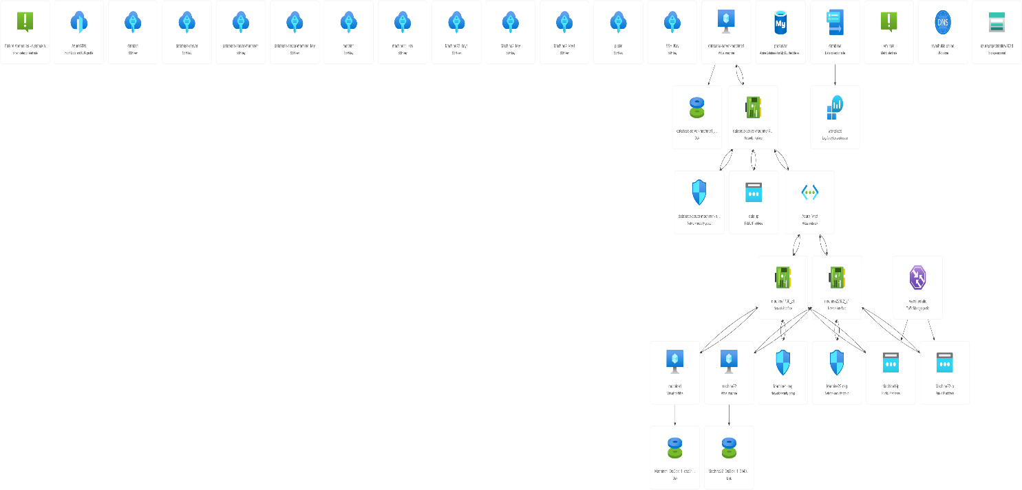

**5.1 Create Virtual Network**

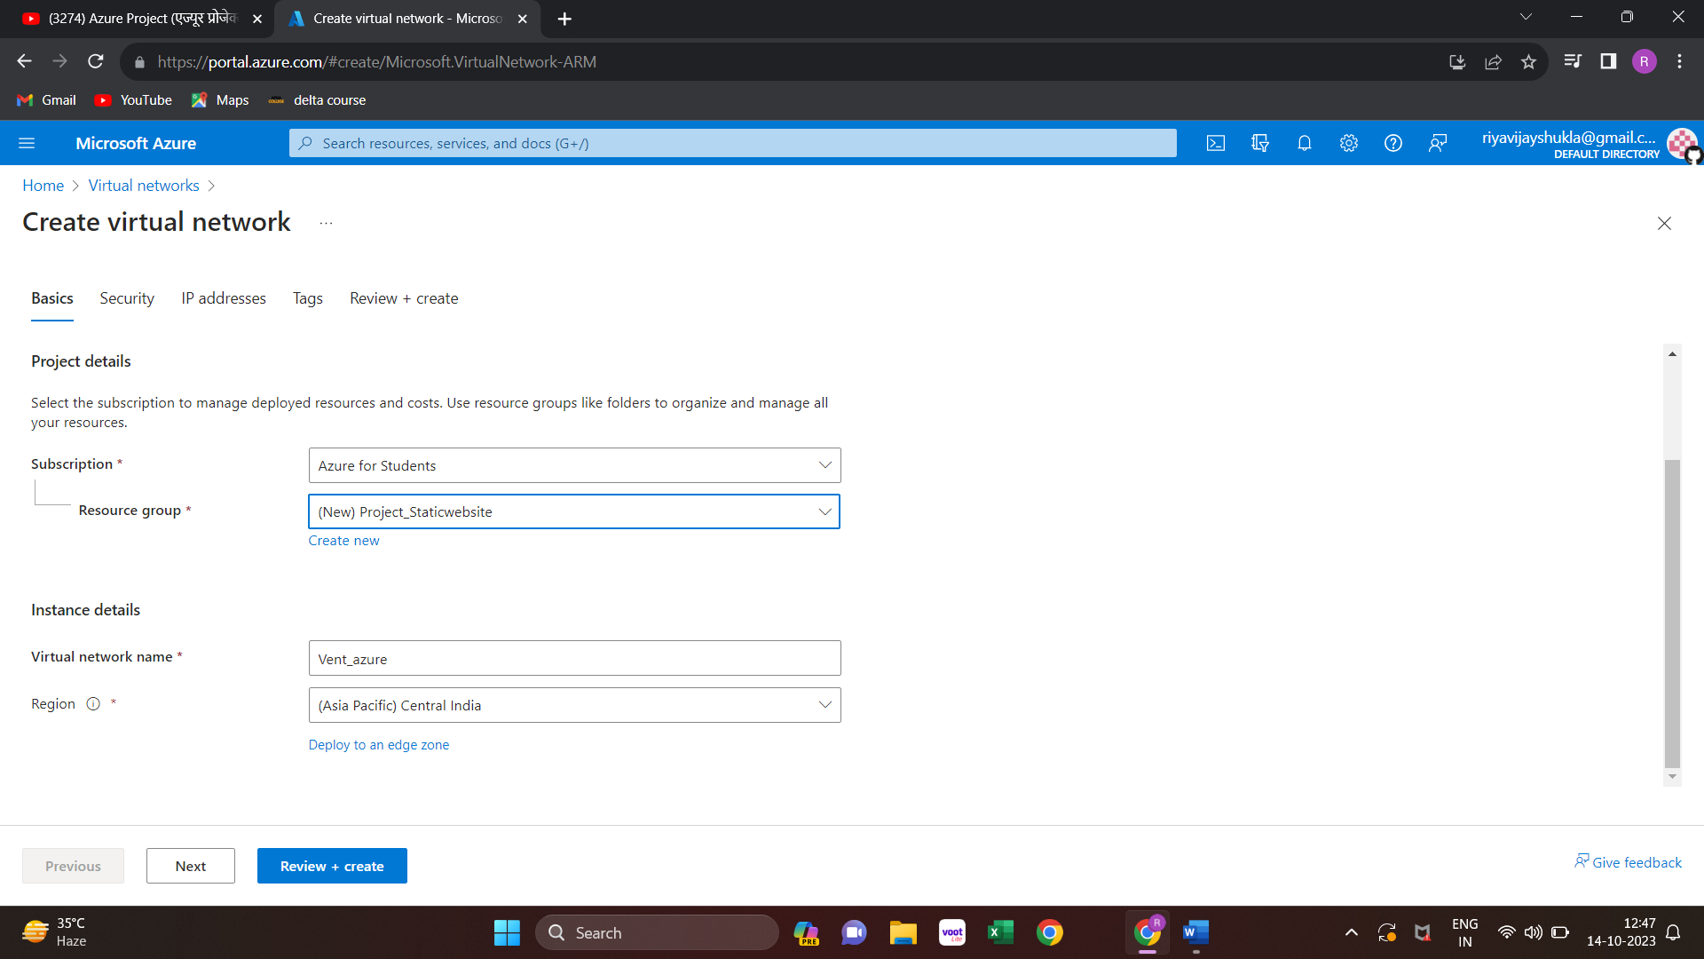

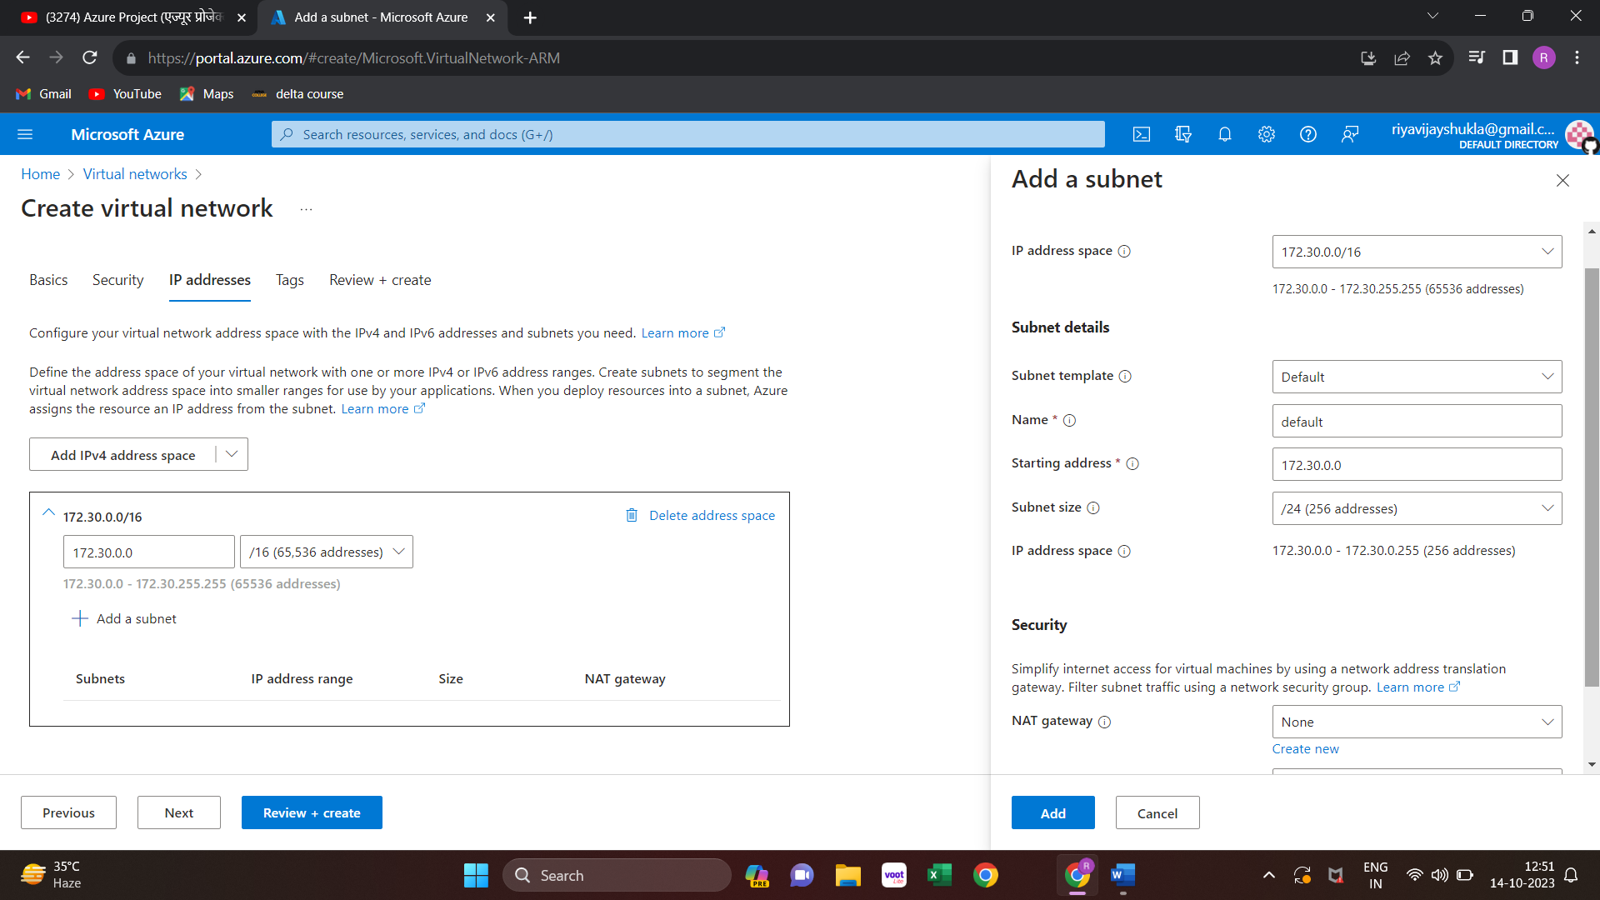

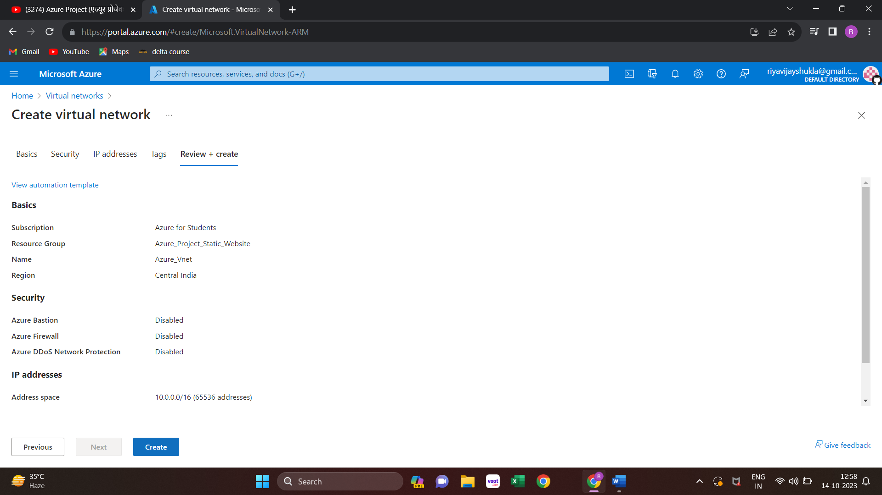

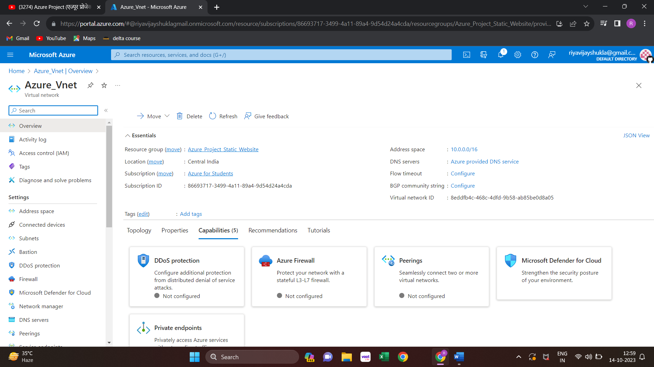

**5.2 Create Virtual machine**

**Create Machine 1 in subnet1:**

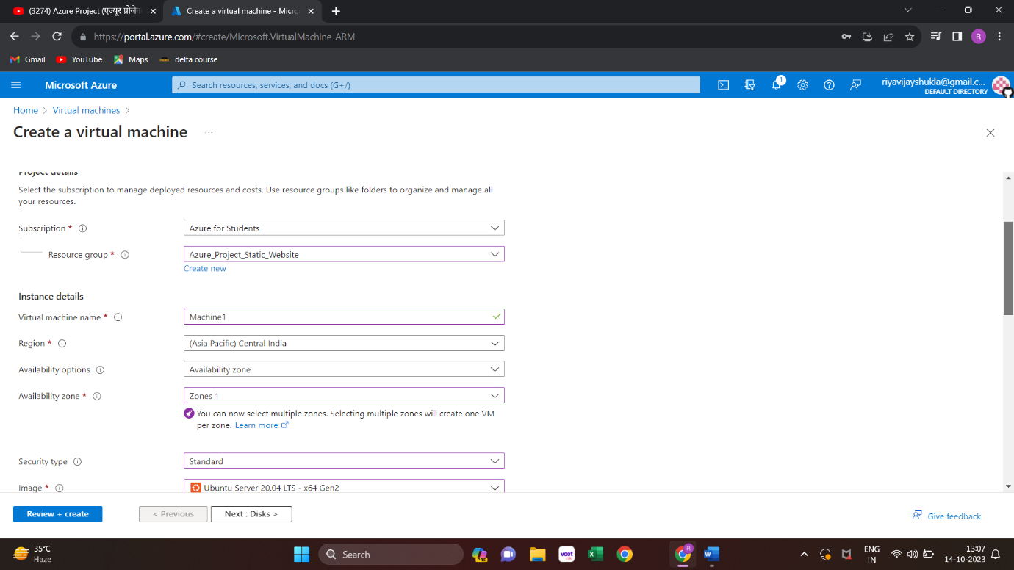

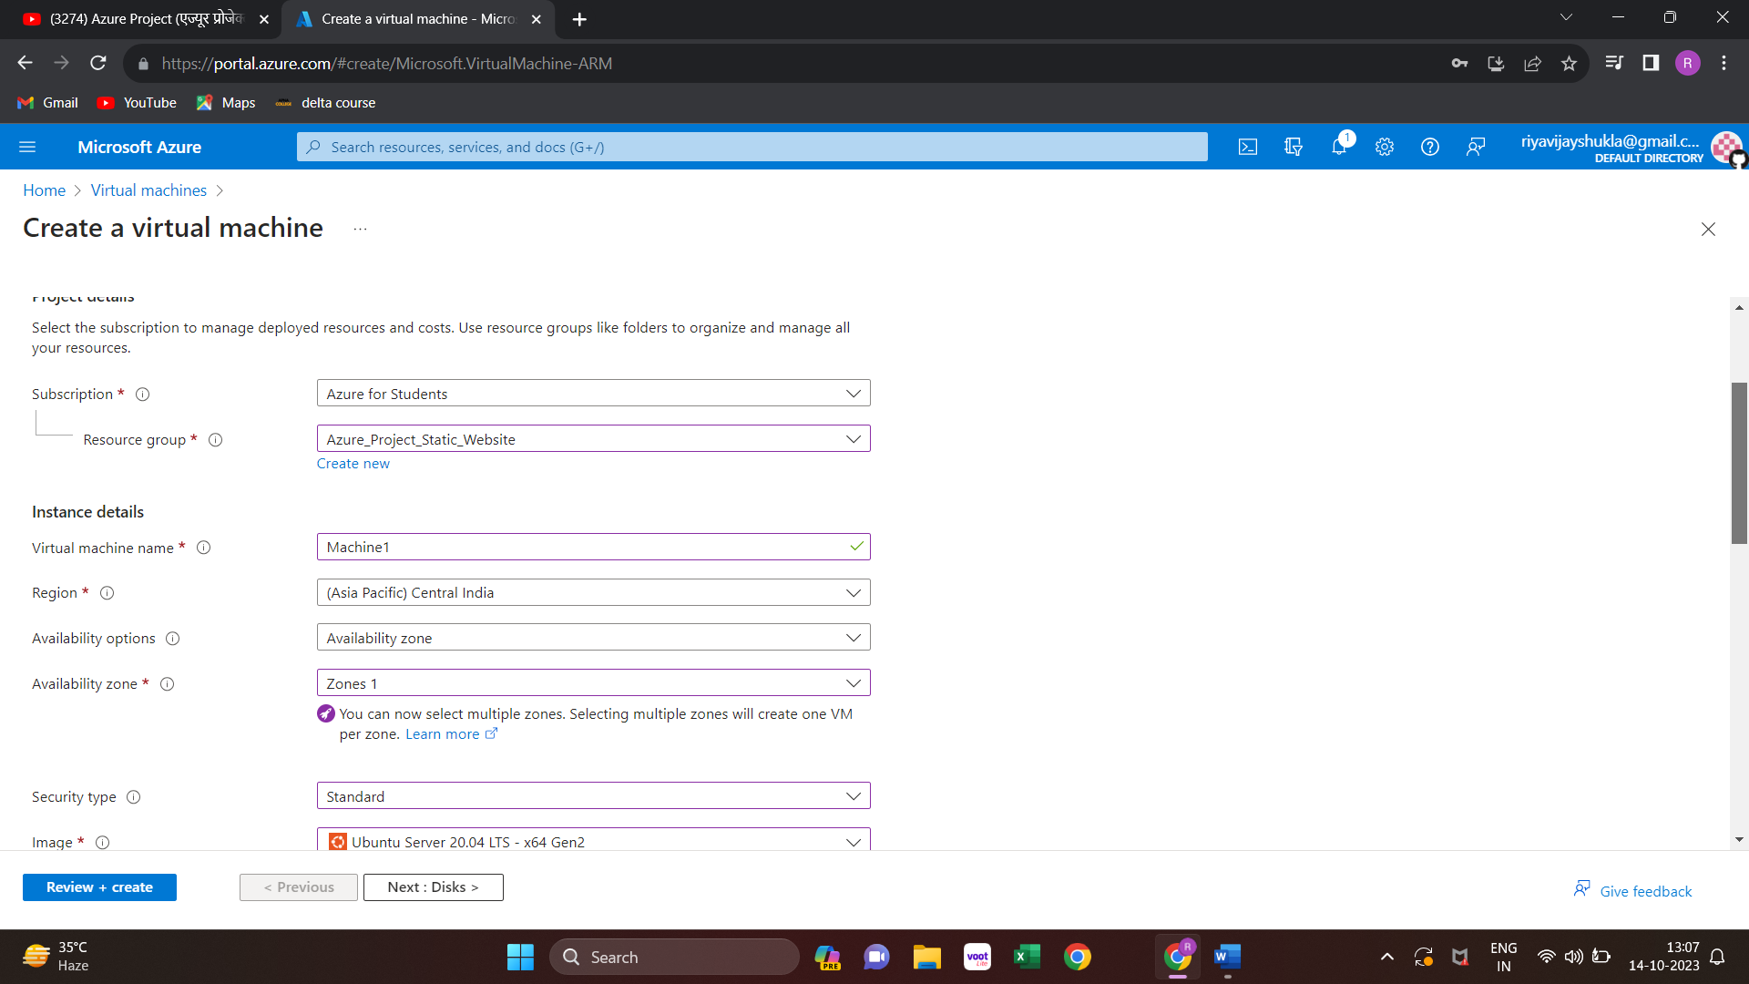

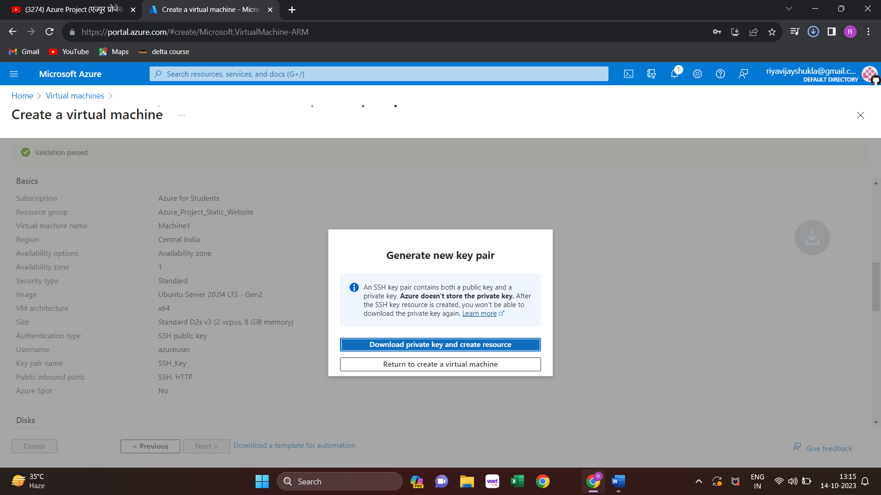

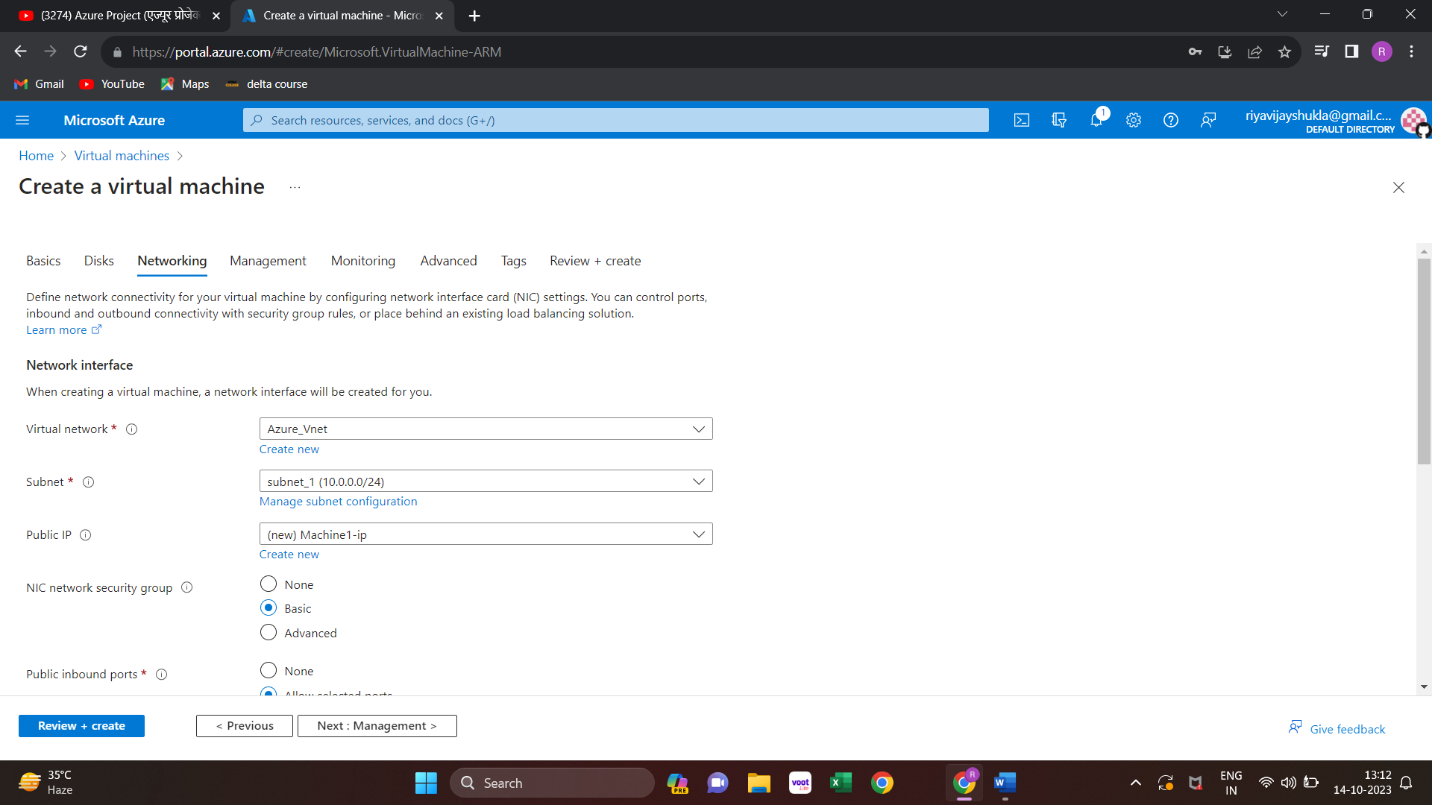

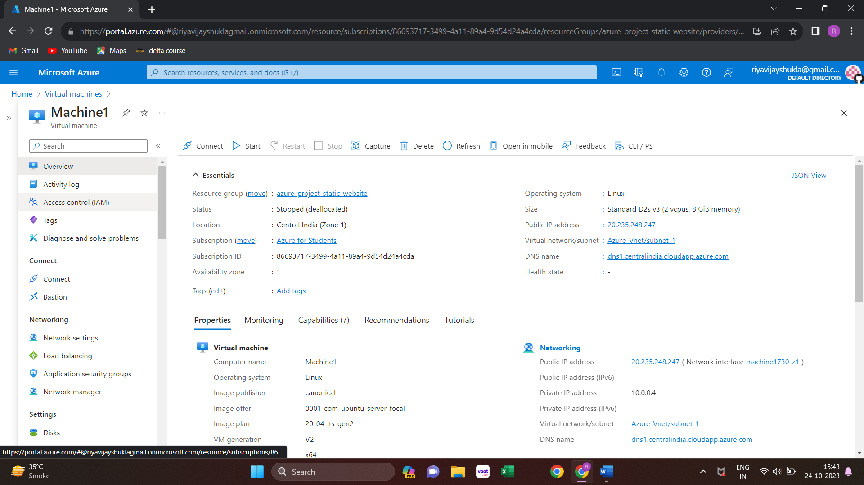

**Create machine2 in subnet1**

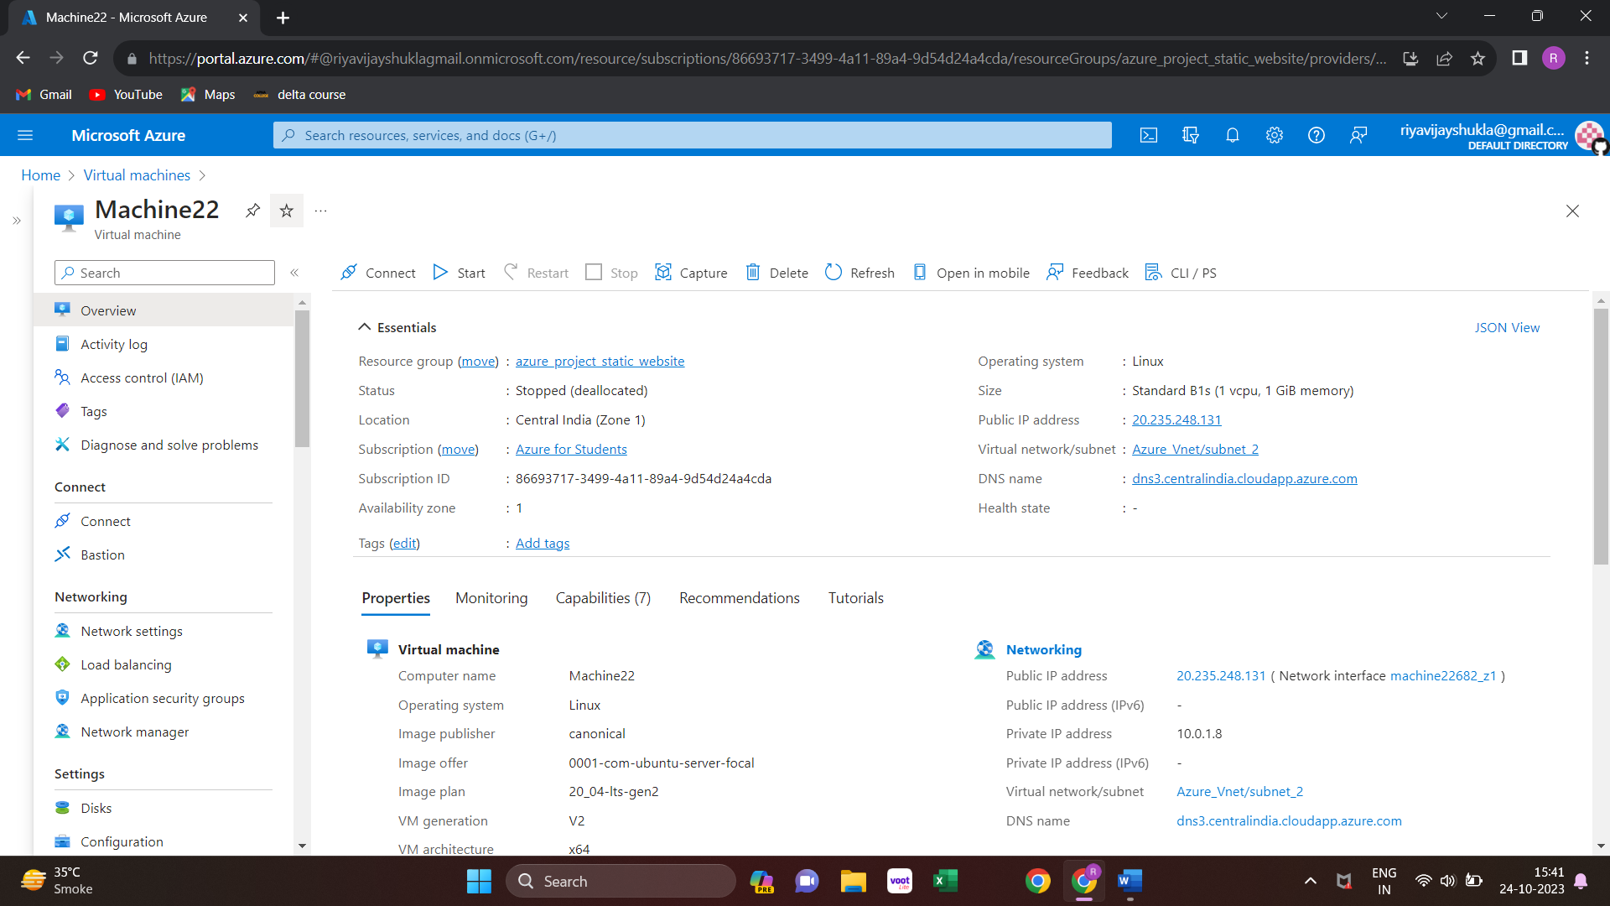

**Create virtual machine for database in subnet2**

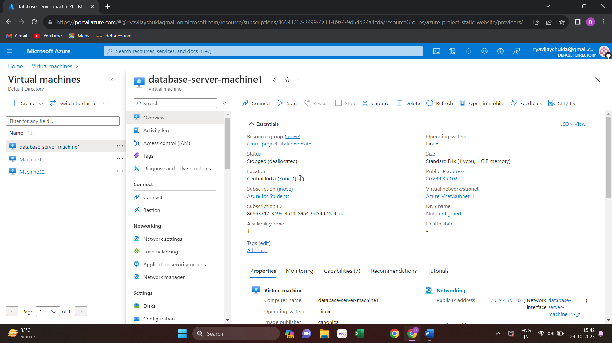

**Create Azure MySqL database:**

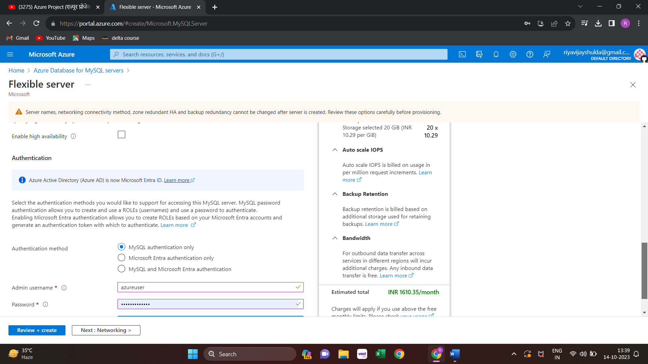

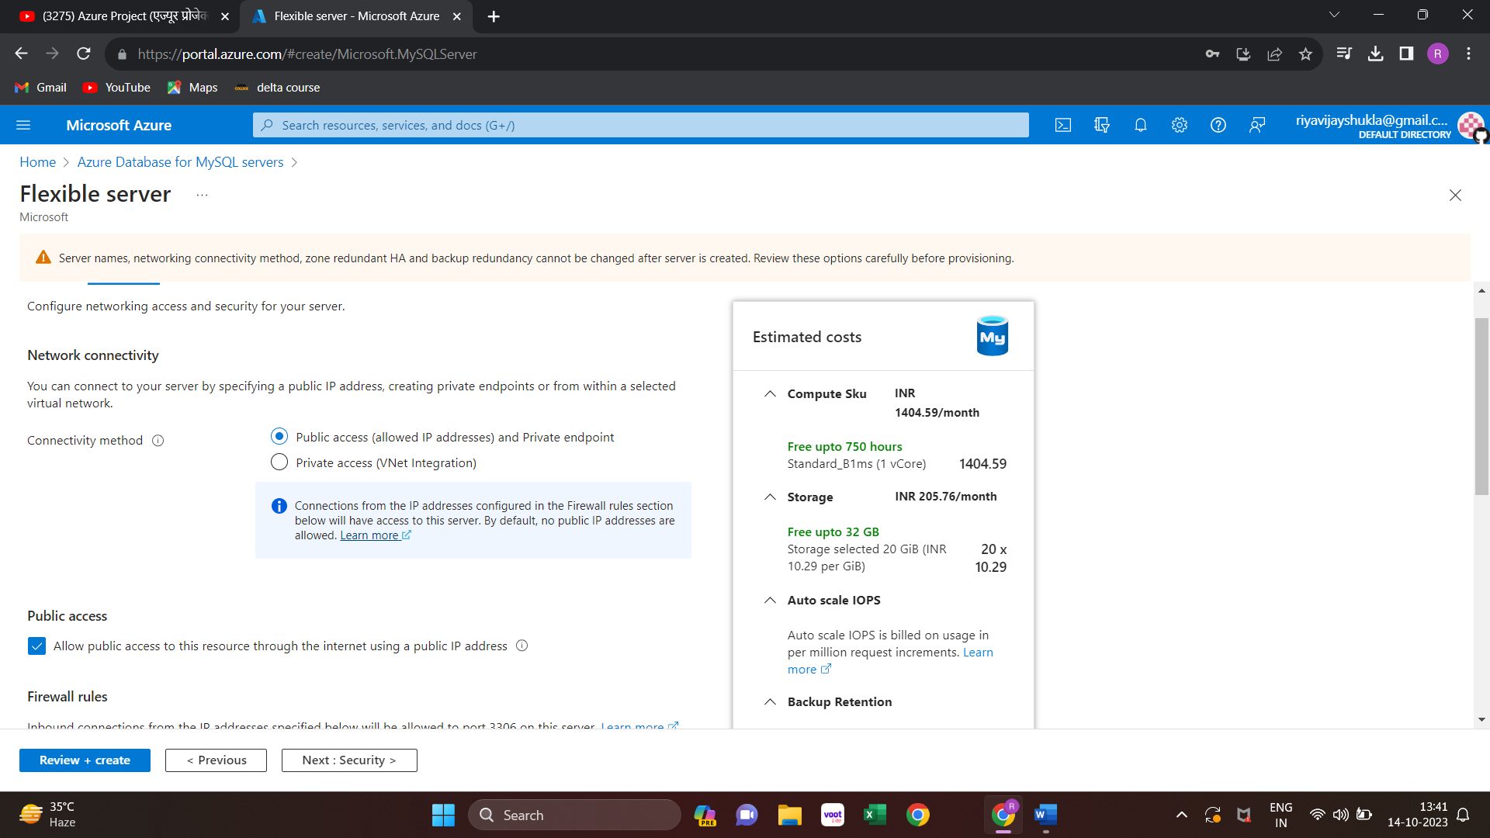

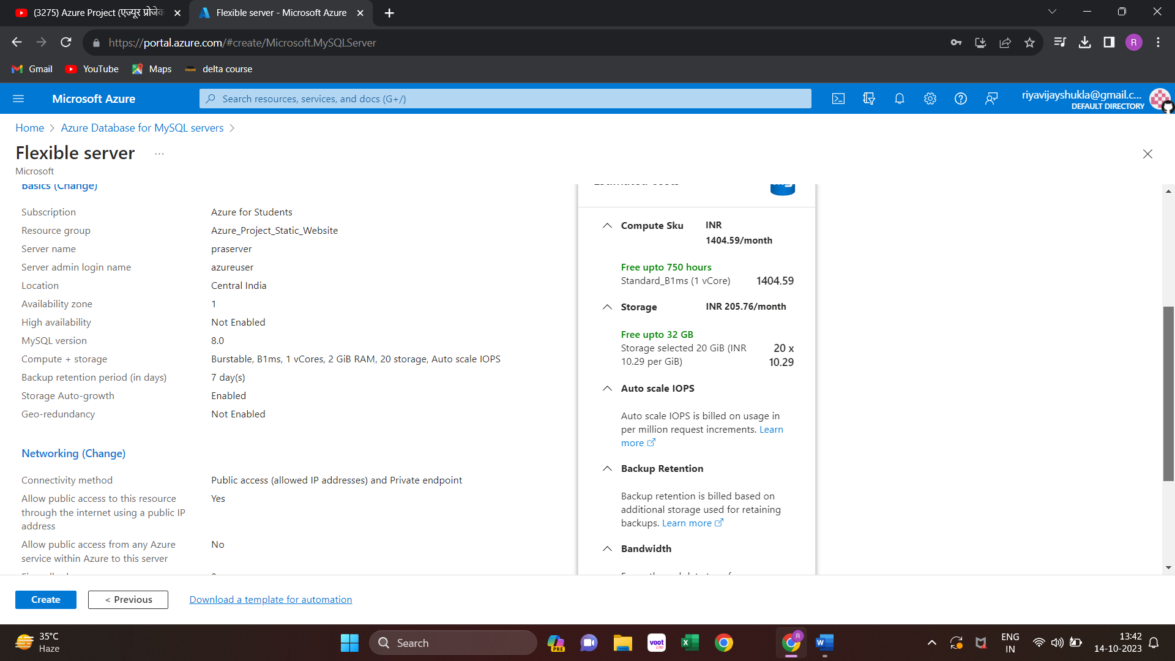

**Install Mysql database in Machine3(Database Server Machine)**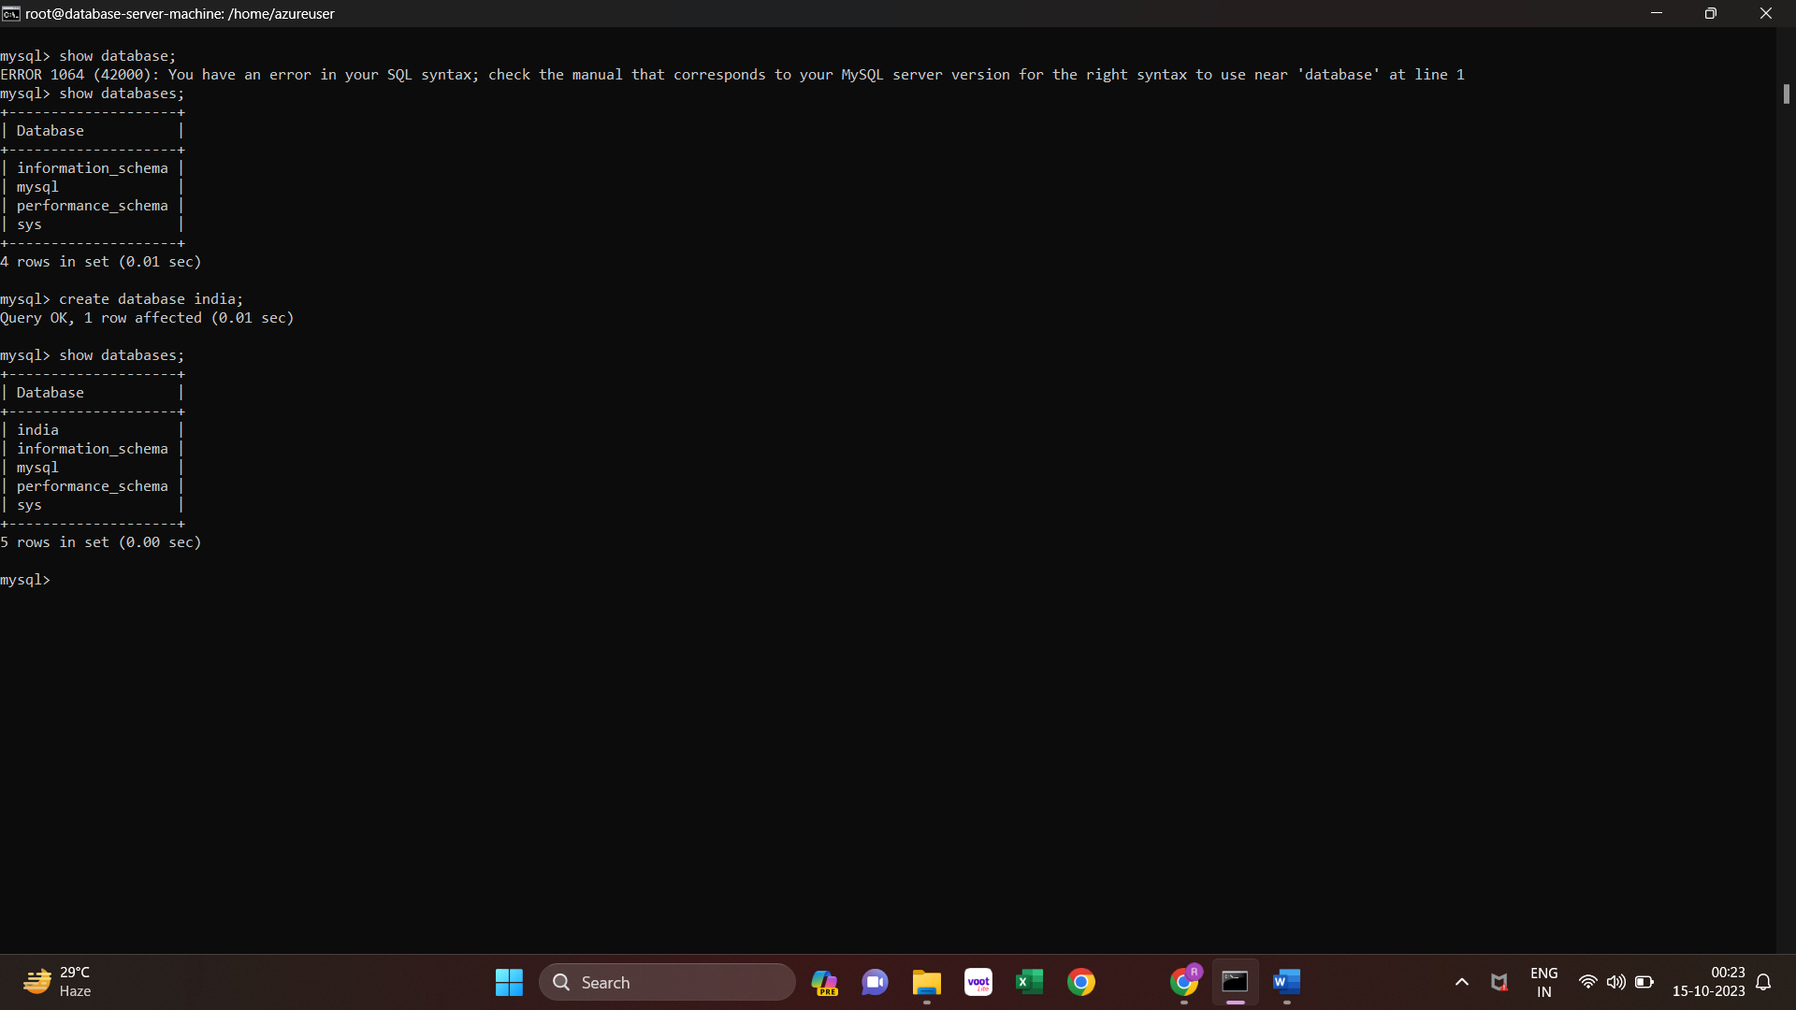

**Create Azure CDN:**

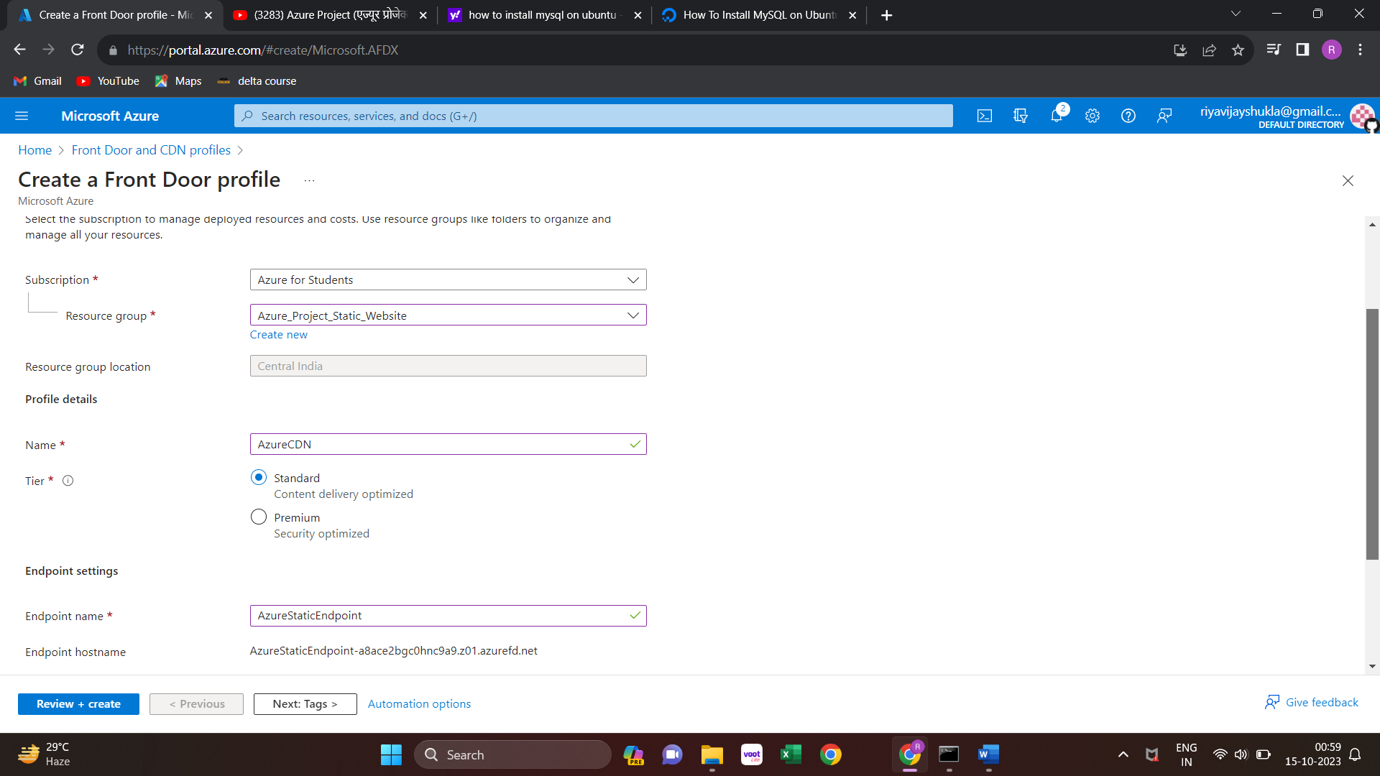

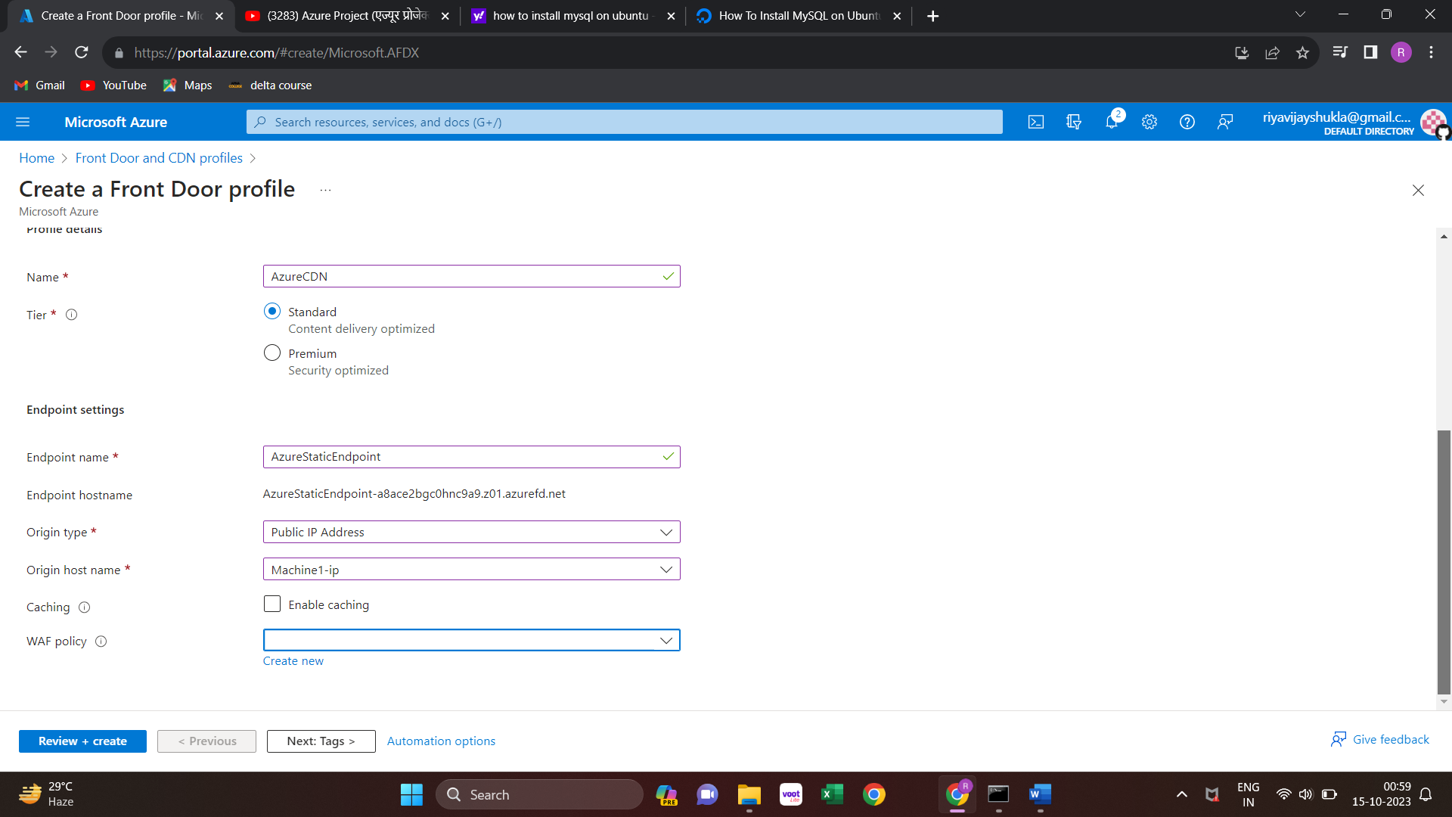

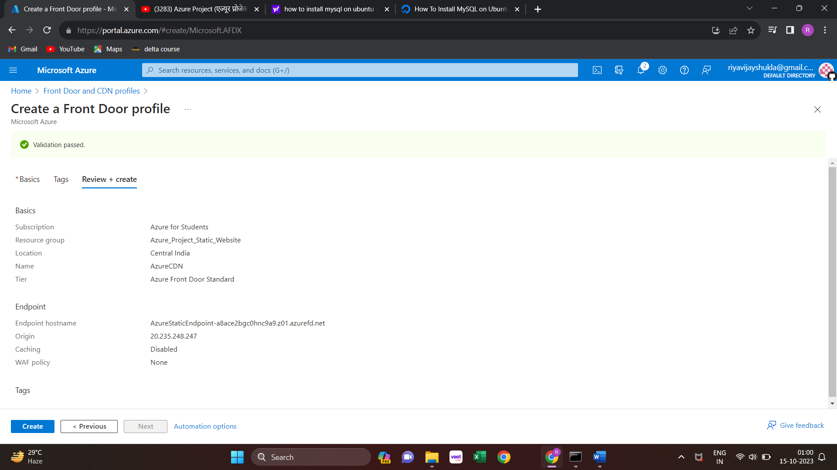

**5.3 Deploy code on virtual machine using Github**

**Deploy same code on machine1 and Machine2**

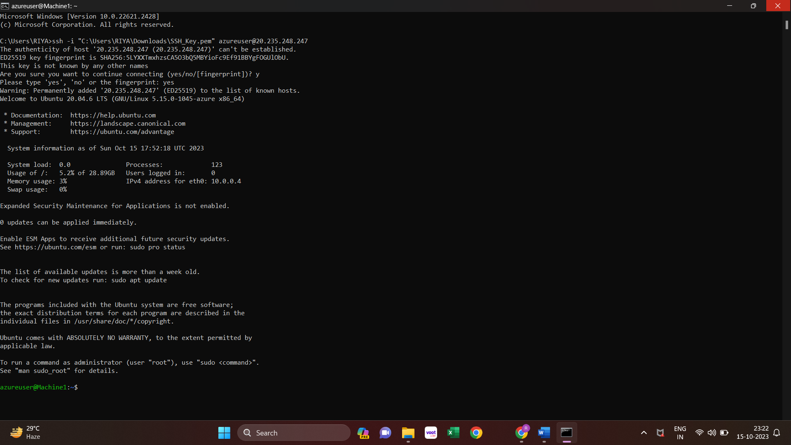

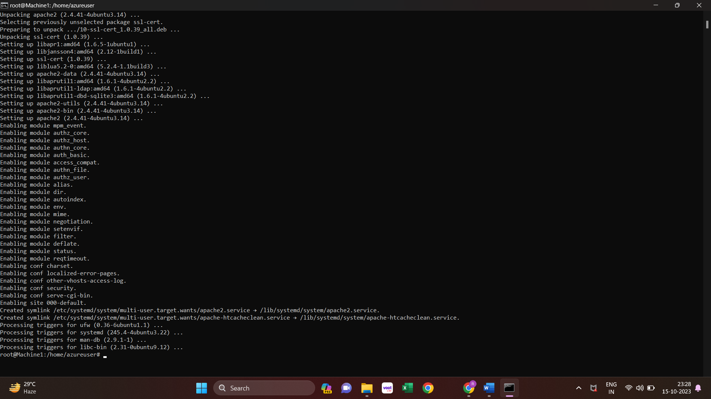

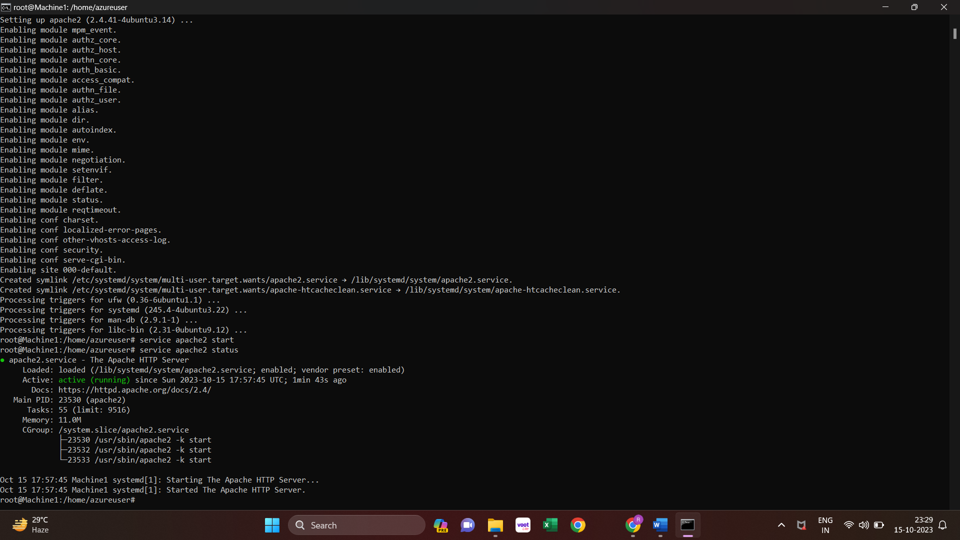

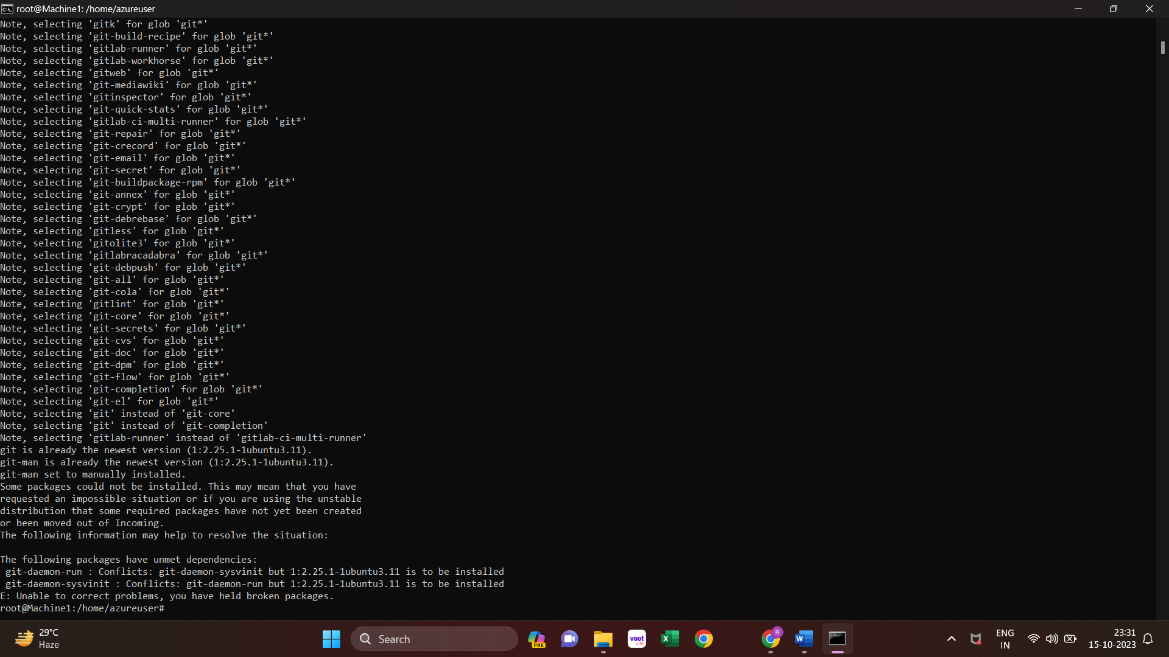

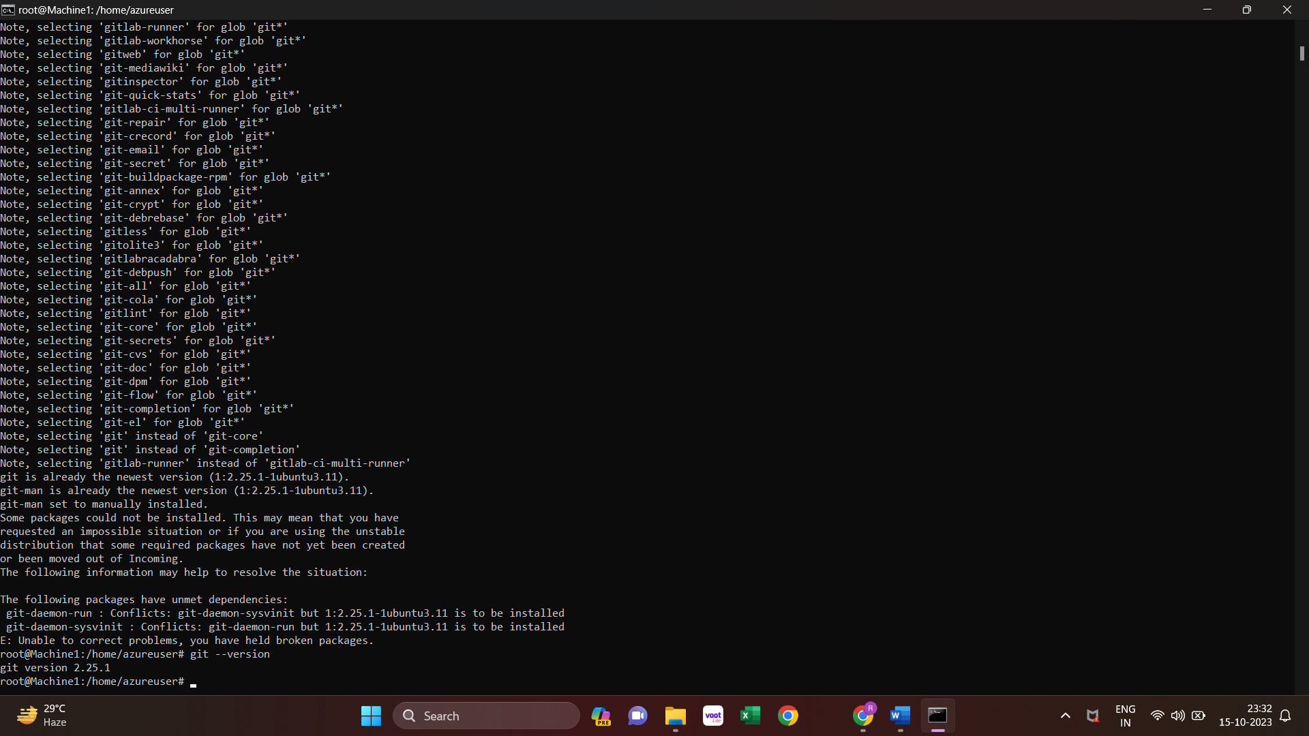

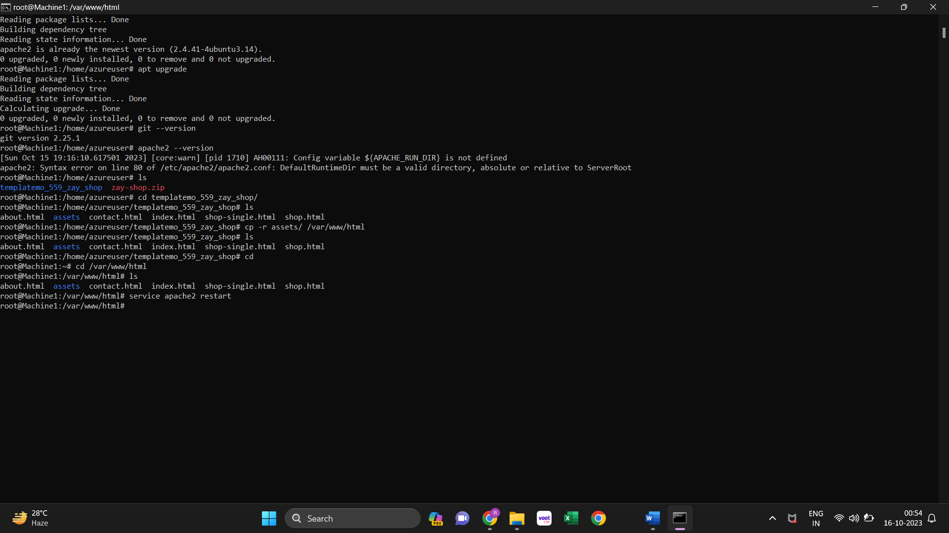

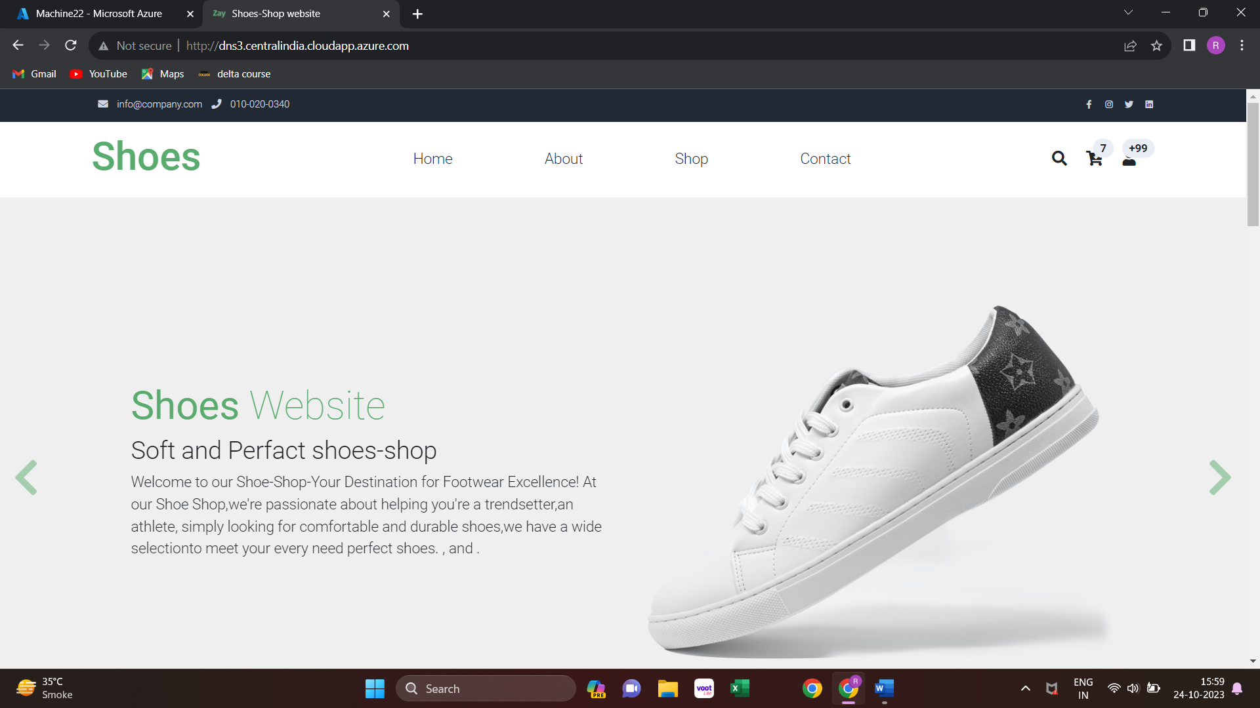

**Commands:**

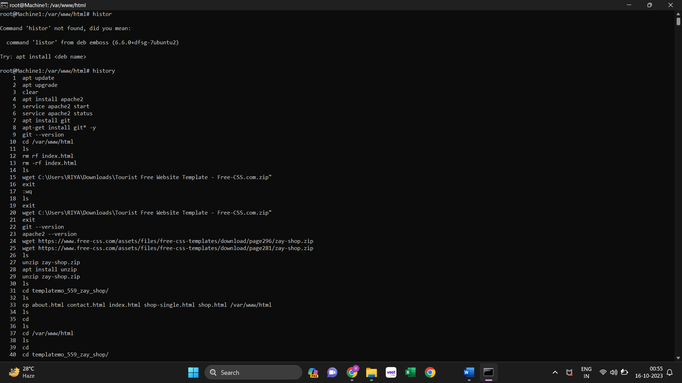

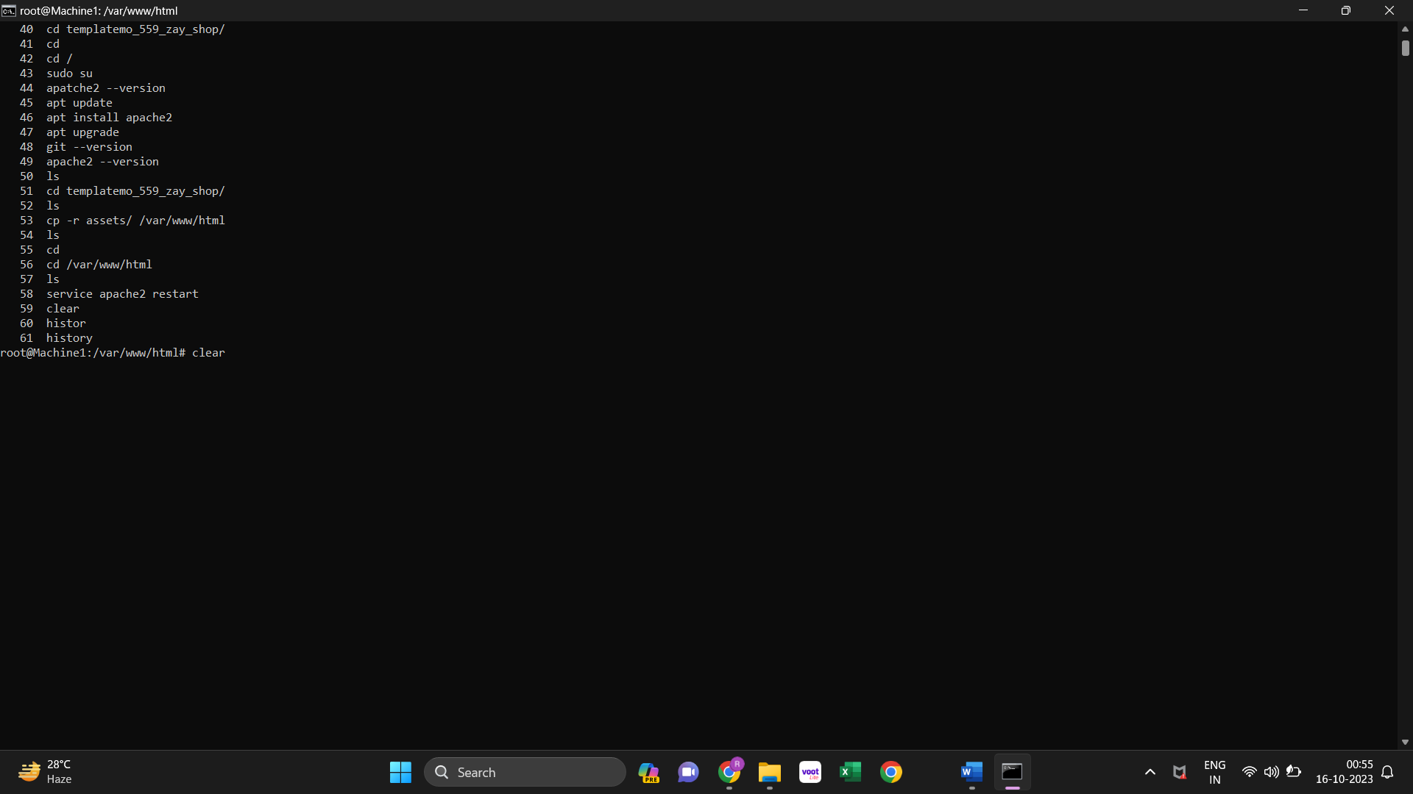

**5.4 Create DNS Zone for hosting**

Step 1:Visit Hostinger’s website

Step 2:Search for Your Domain(riyashukla.online)

Step 3:Review your cart, sign in or Create an account

Step 4:Place your order confirm

Step 5:Domain Registration

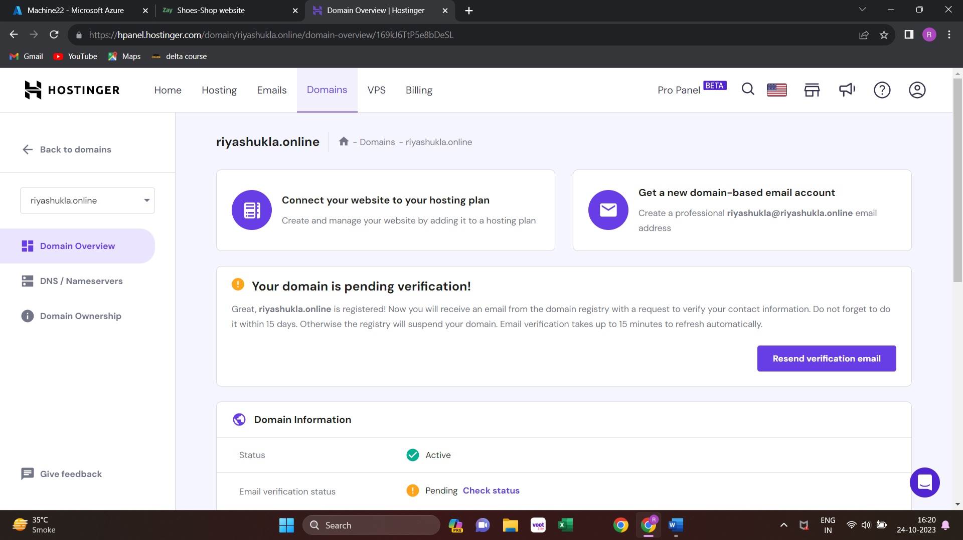

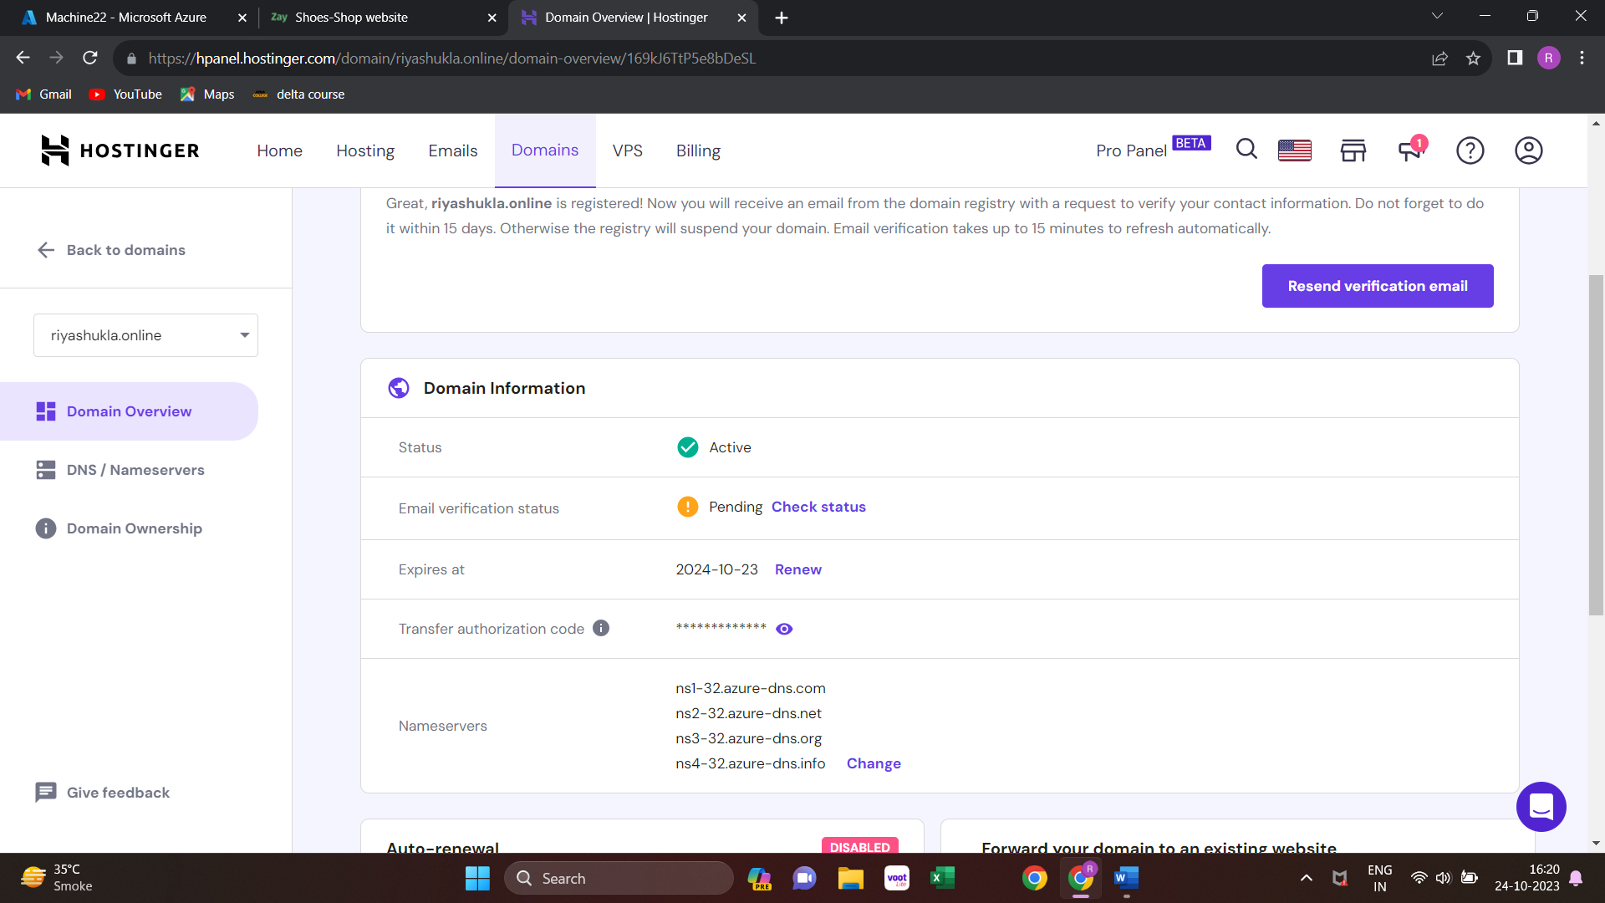

* Create a DNS zone to host your website domain name .This means that when someone types in your websites address in a web browser, the DNS zone directs them to the correct destination.In this setup, its linked to the traffic manager

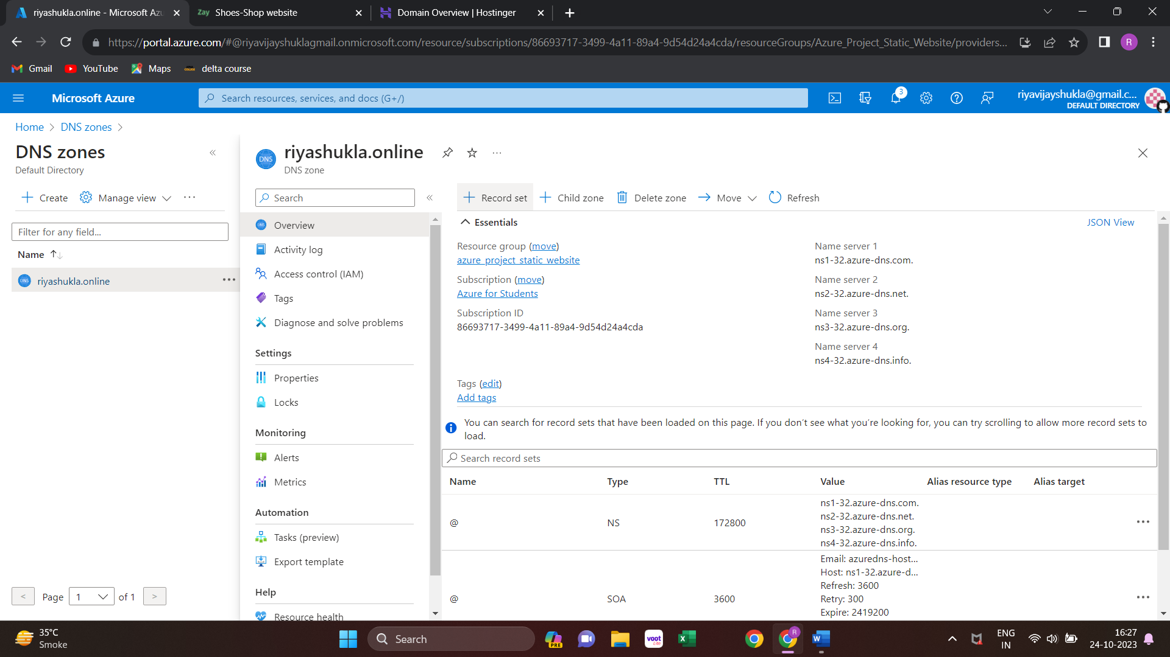

**5.5 Create traffic manager (Priority based)**

Traffic Manager to distribute incoming requests between the two VMs in subnet1.It improves the availability and Performance of your website by load balancing.

* Now we need to create Traffic Manager it distrubuting the Users request to the apporopriate Virtual Machine within your subnet 1.This ensures that your website loads efficiently and reliably for your visitors.
* Create a Traffic Manager Profile:
* In the Azure Portal, search for and select "Traffic Manager profiles."
* Click the "+ Add" button to create a new Traffic Manager profile.
* Follow the prompts to configure the profile with your desired settings, including routing method (e.g., Priority, Weighted, Geographic), and add the endpoints (the VMs in your Subnet 1).
* We select routing method (Priority)

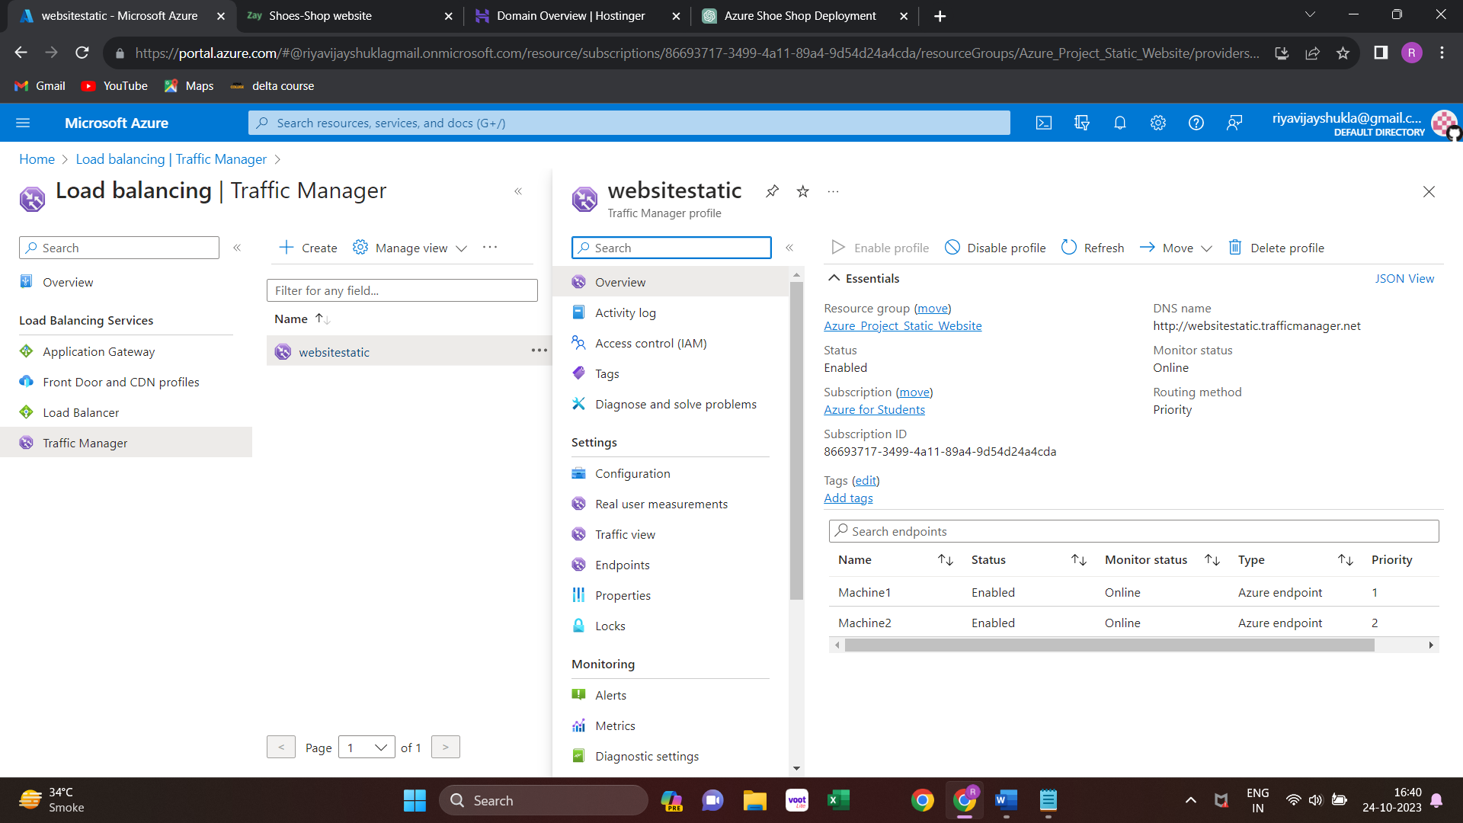

**Link Traffic Manager to the DNS zone**

* In the DNS Zone settings, under "Records," you should create a CNAME (Alias) record that points to your Traffic Manager profile. This is where you connect the DNS Zone to the Traffic Manager.
* Add a CNAME record with a name like "www" or "@", and set its value to the fully qualified domain name (FQDN) of your Traffic Manager profile.

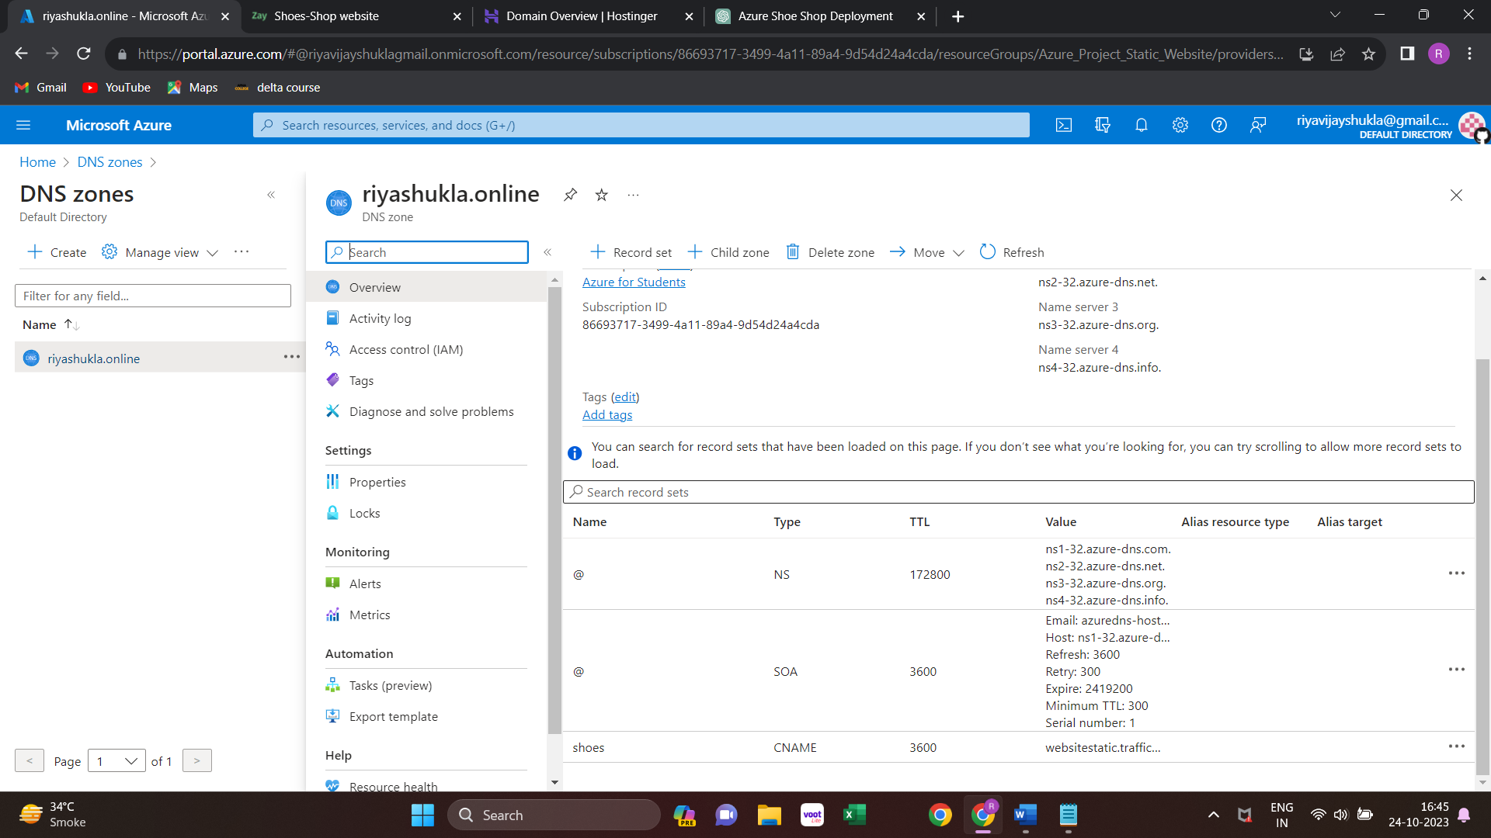

**Update Your Domain Registrar:**

* If your domain is registered with a domain registrar (Hostingr), you need to update the DNS settings there. Log in to your domain registrar's website.
* Change the nameservers or DNS settings to point to Azure's DNS servers (you can find these DNS server details in your Azure DNS Zone settings).

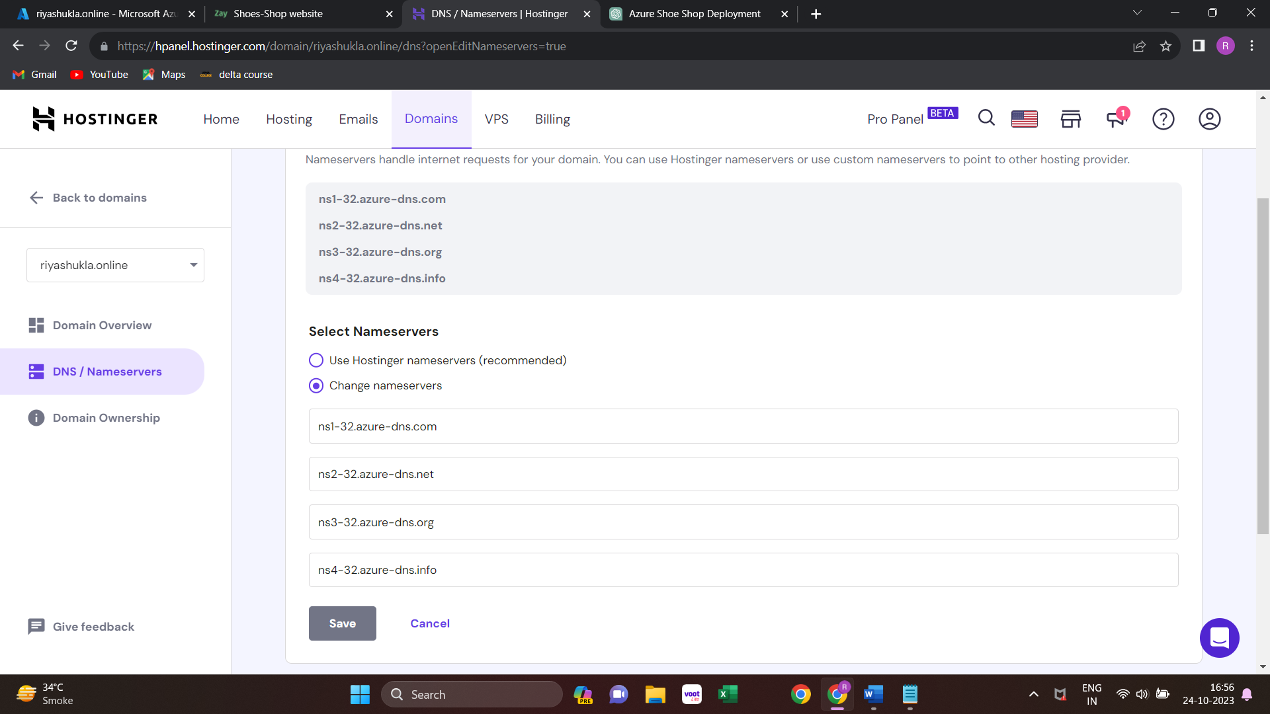

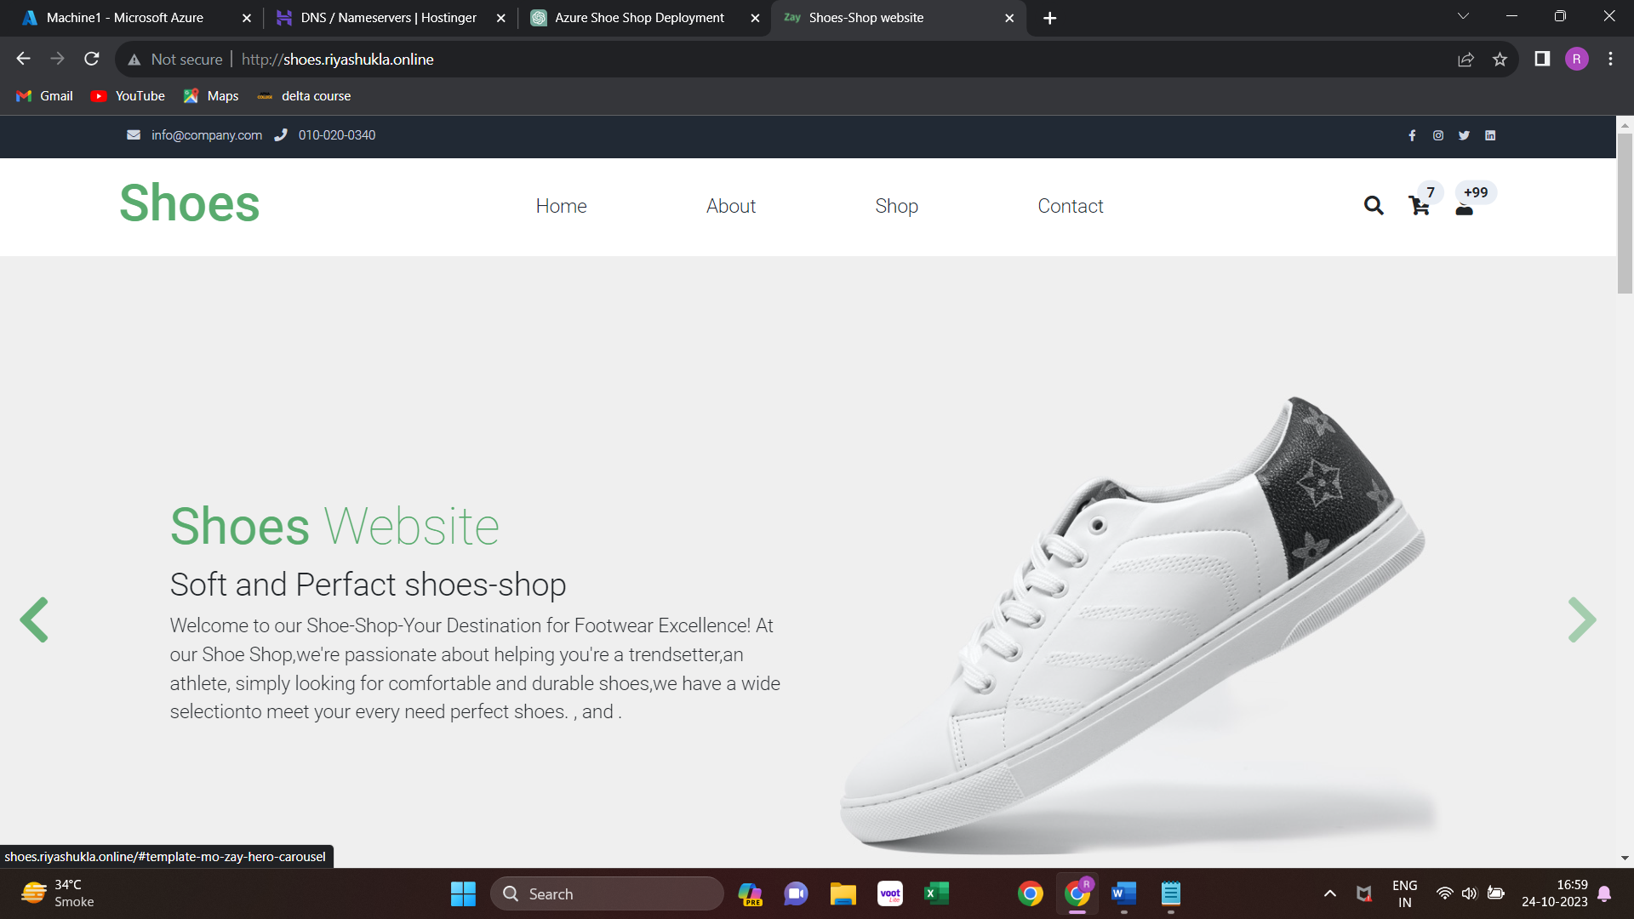

**5.6 Azure Monitor:**

Monitoring in Azure is a crucial aspect of managing and maintaining the health, performance, and security of your cloud resources. Azure provides a comprehensive set of monitoring and management tools. Here's an overview of how monitoring works in Azure:

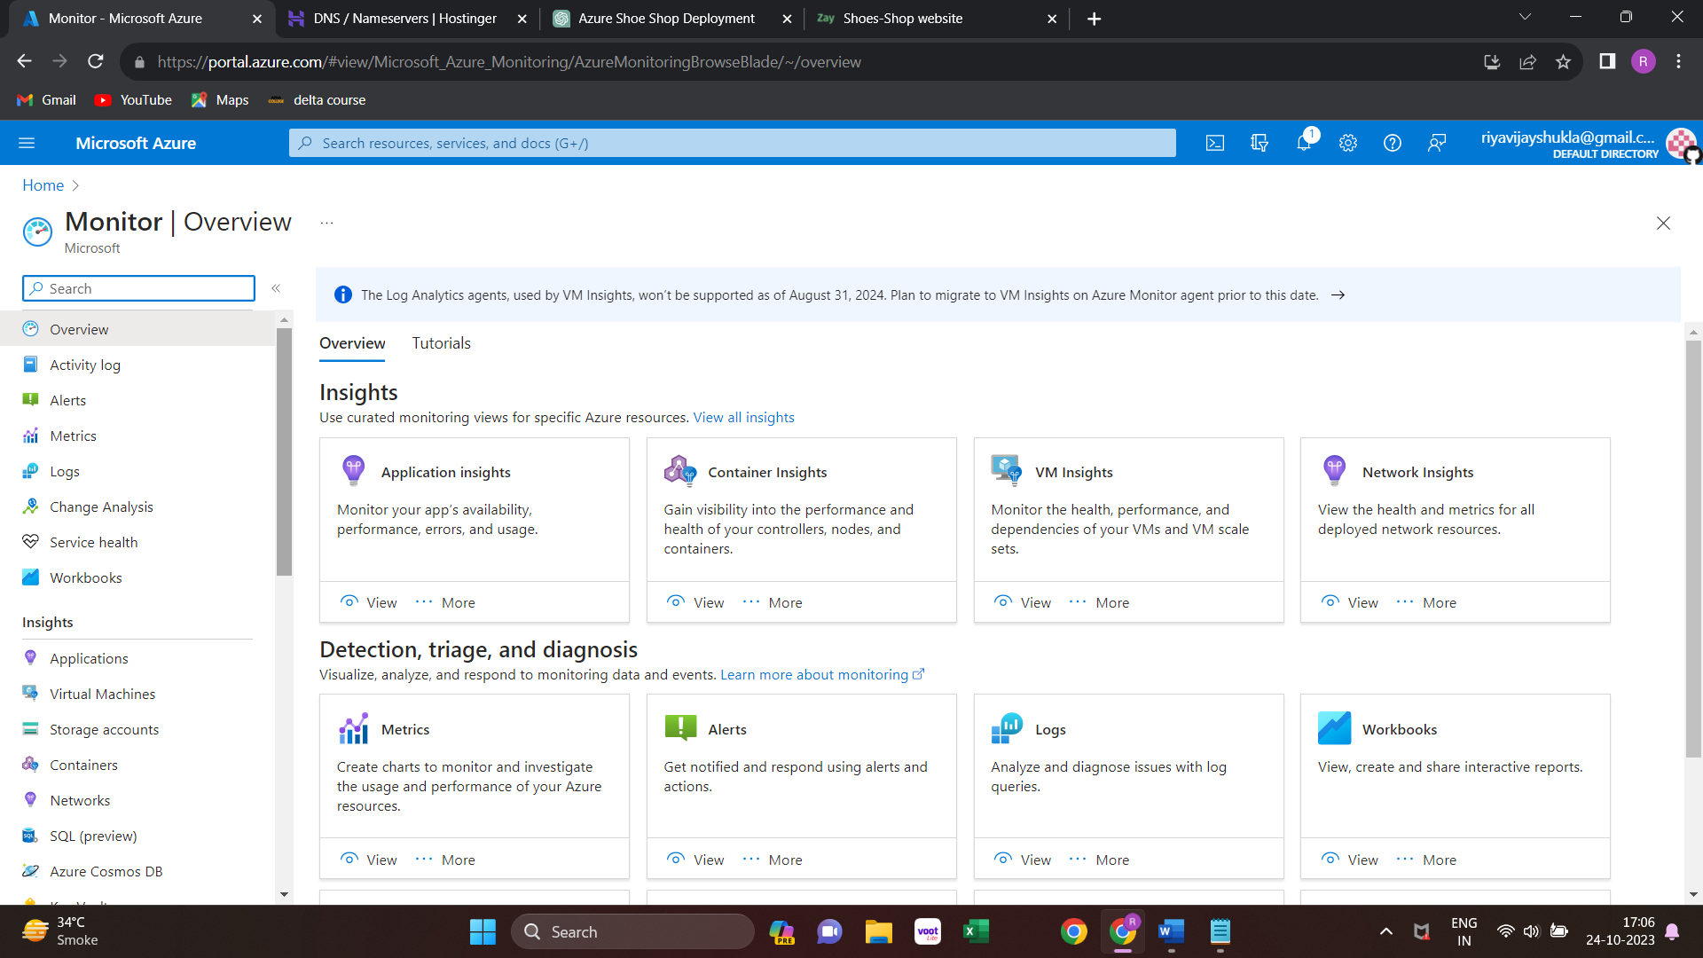

**Azure Alerts:** You can configure alerts to notify you when specific conditions are met. For example, you can set up alerts for high CPU usage, low memory, or any other metrics. These alerts can be sent to various notification channels, including email, SMS, or even third-party services like Slack.

**Azure Monitor for VMs:** If you're running virtual machines (VMs) in Azure, you can use this service to collect performance and health data for those VMs.

**Metrics:** Metrics are numerical data collected from your resources. Azure Monitor collects, stores, and analyse metrics to help you understand how your resources are performing. You can set up alerts based on these metrics to be notified of any issues.

**Azure Application Insights:** This service is part of Azure Monitor and is focused on application performance monitoring. It helps you track the performance and usage of your web applications and other services.

**Azure Alerts:**

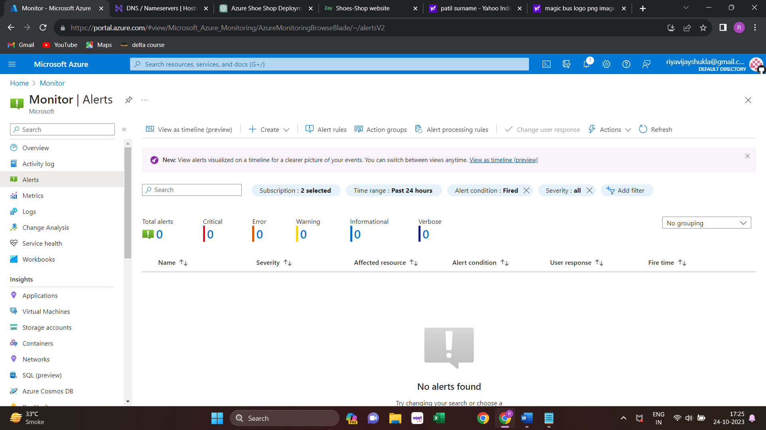

**Metrics:**

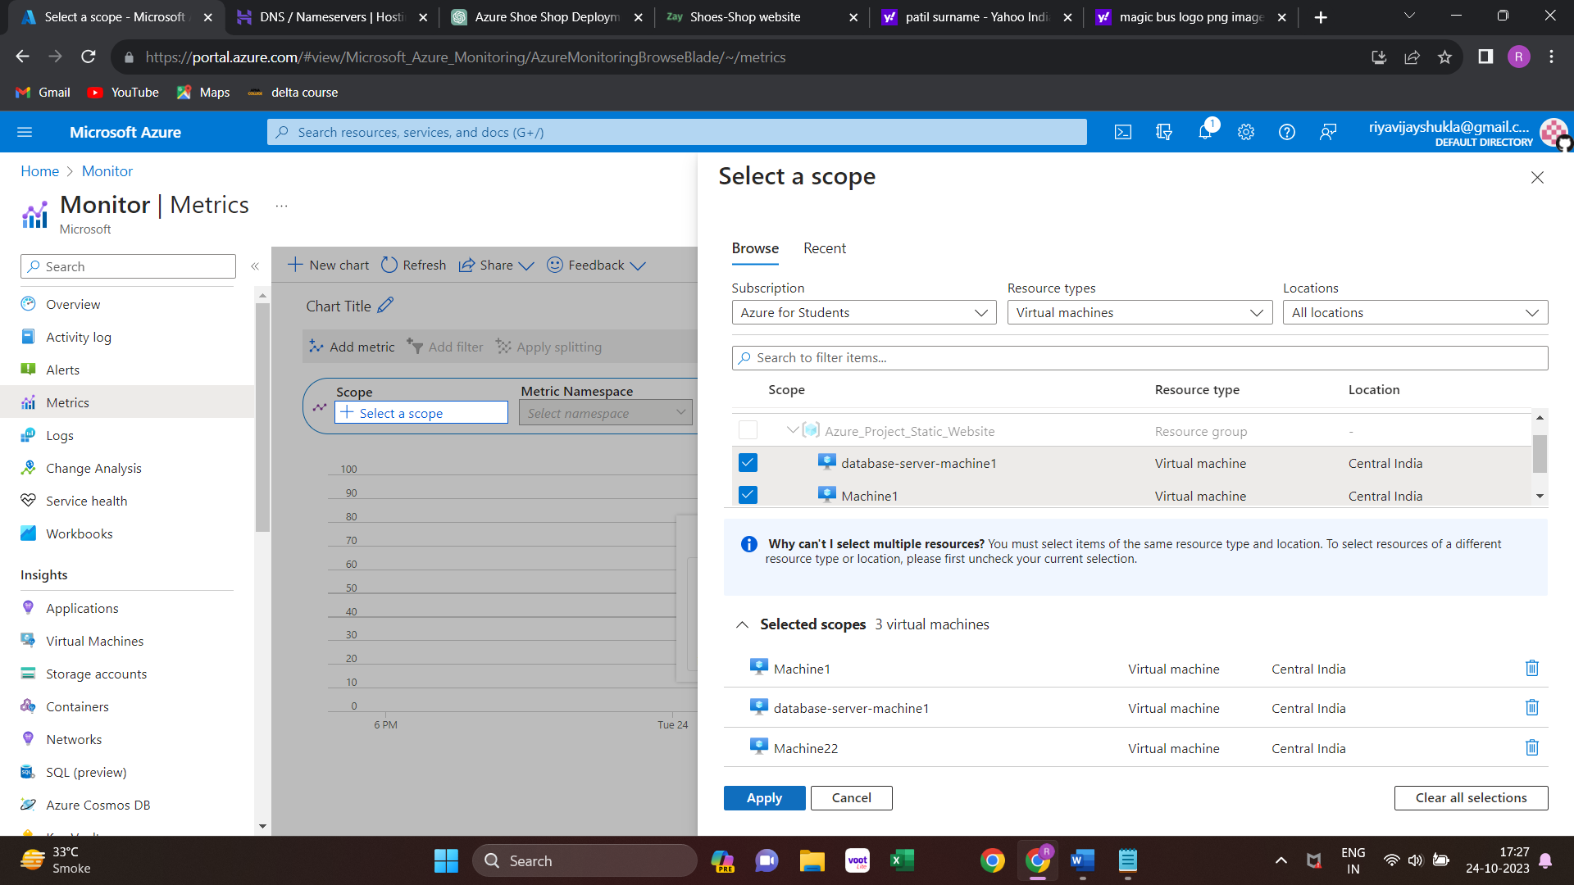

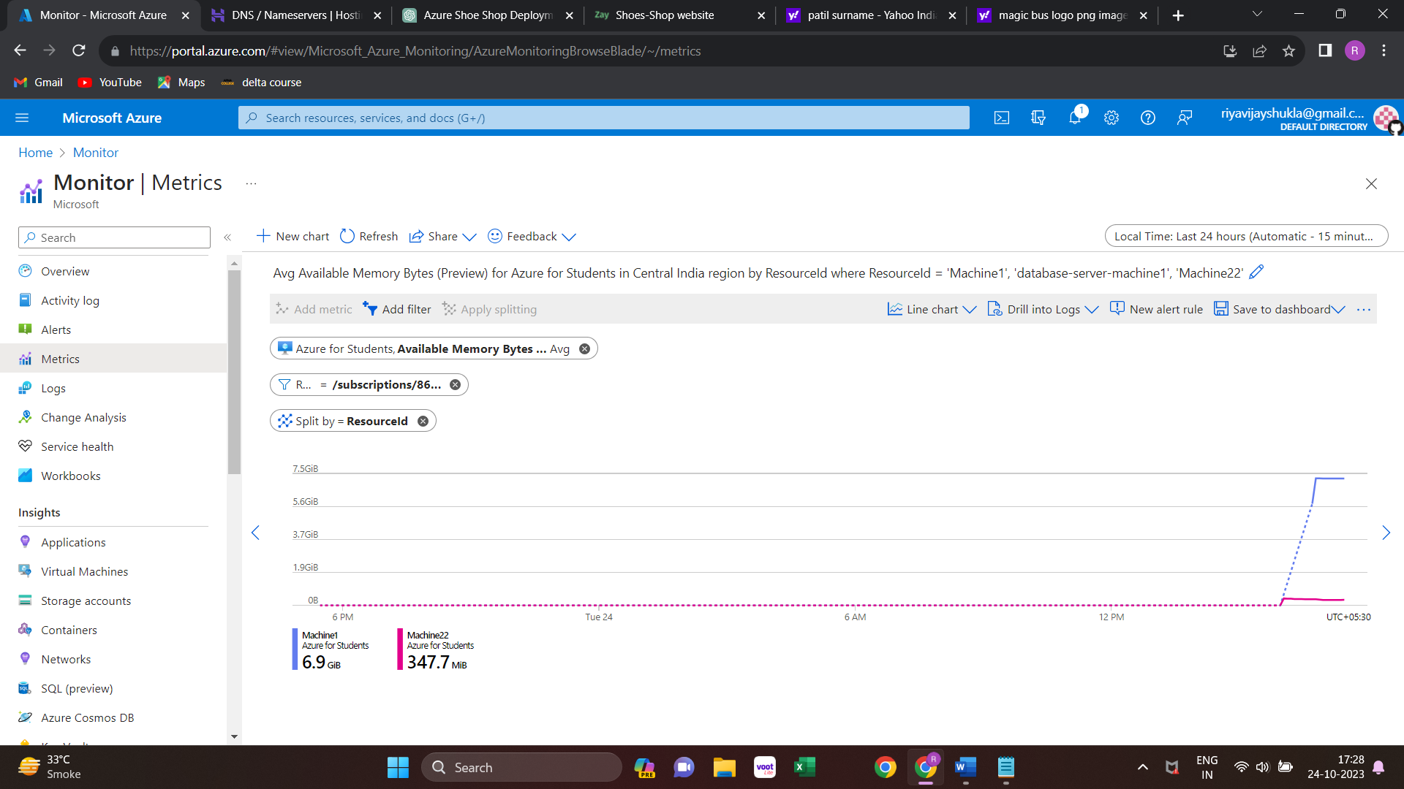

**Network**

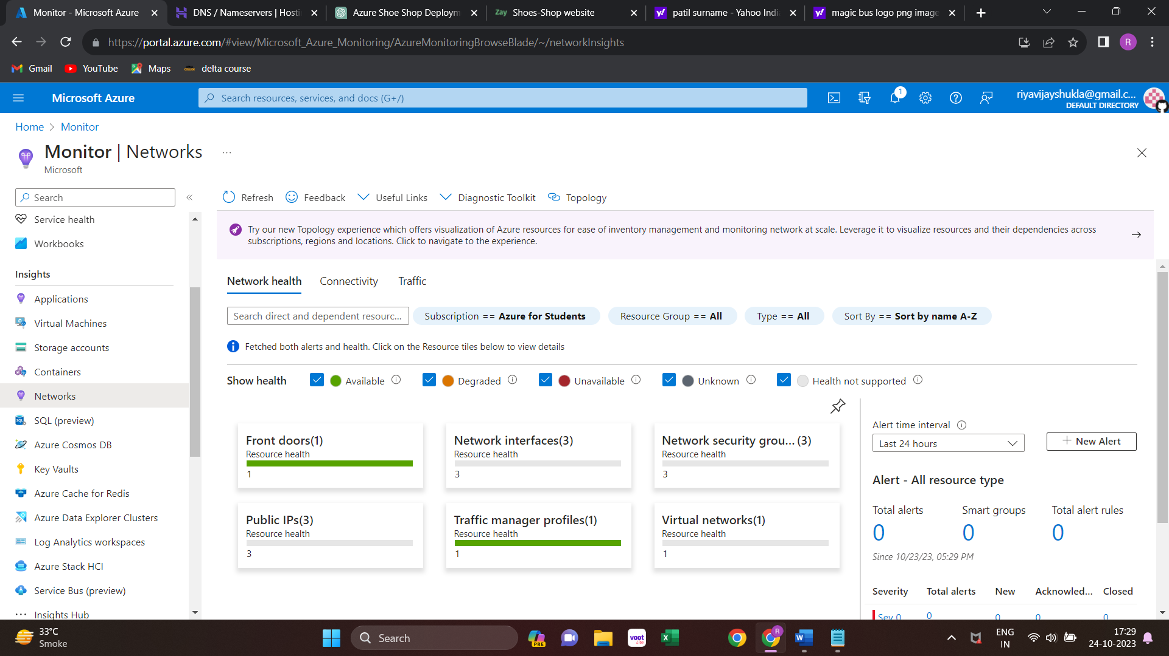

**Chapter 6. Conclusion**

In summary, our project successfully leveraged Azure's cloud computing capabilities to create and deploy a shoe shop website with a strong focus on availability, performance, and user experience. The use of Virtual Networks and Subnets ensured a secure and organized infrastructure. Traffic Manager efficiently managed incoming traffic, while DNS Zone facilitated seamless domain name resolution.

Our commitment to monitoring and alerts helped us stay proactive in maintaining the website's reliability. Lastly, the Azure CDN optimized content delivery, making our site faster and more responsive to our customers.

In conclusion, by harnessing Azure's cloud services and following best practices, we've not only created a functional online presence but also ensured that it's accessible, reliable, and responsive, providing an excellent shopping experience for our customers. This project demonstrates the power of cloud computing in enabling e-commerce businesses to thrive in the digital age.